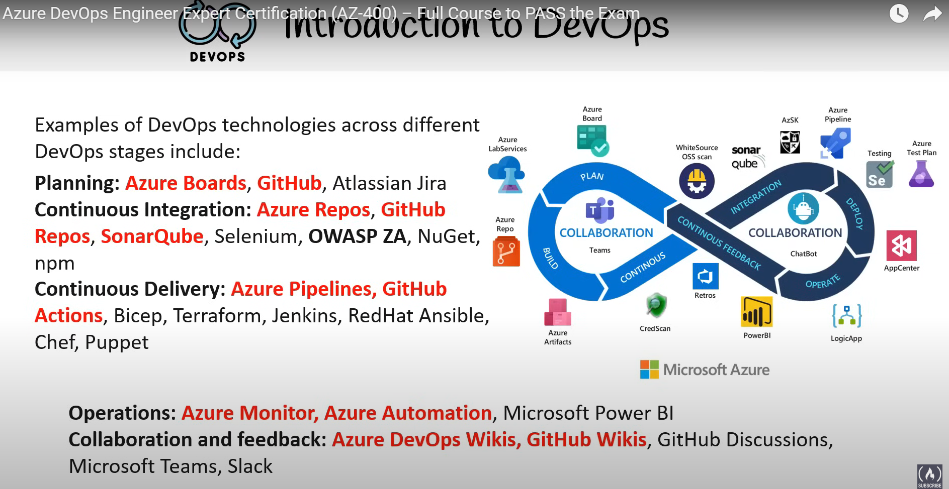

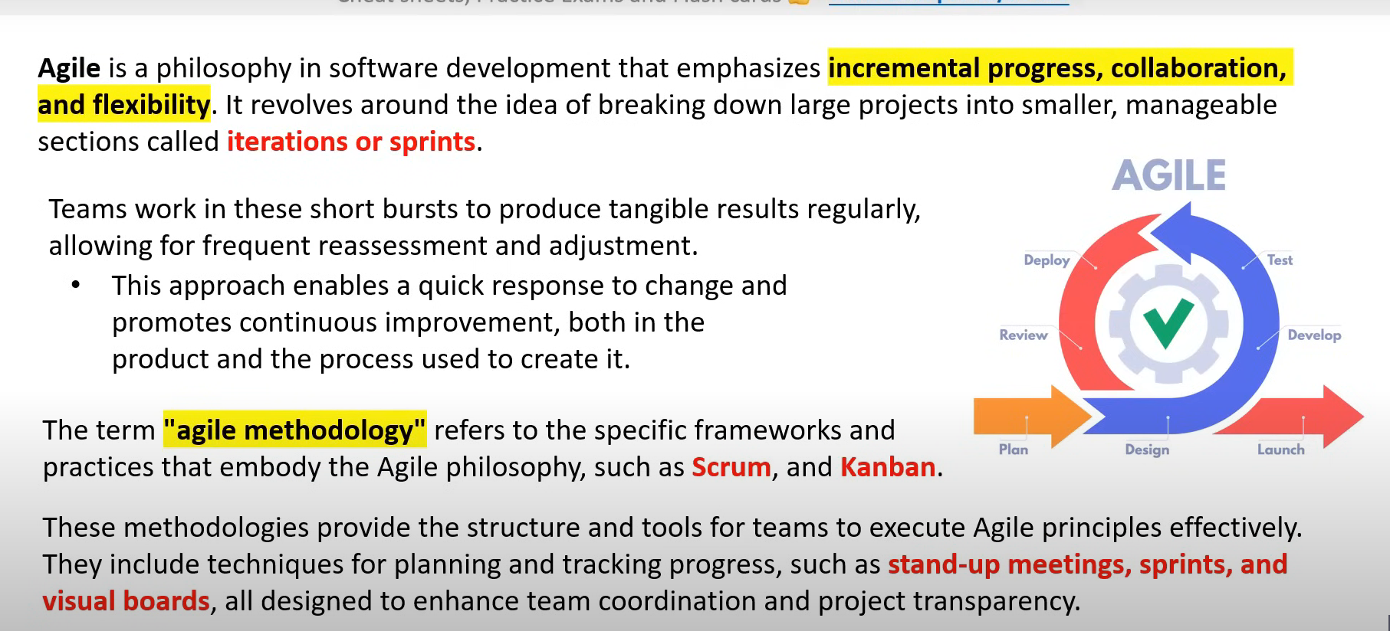

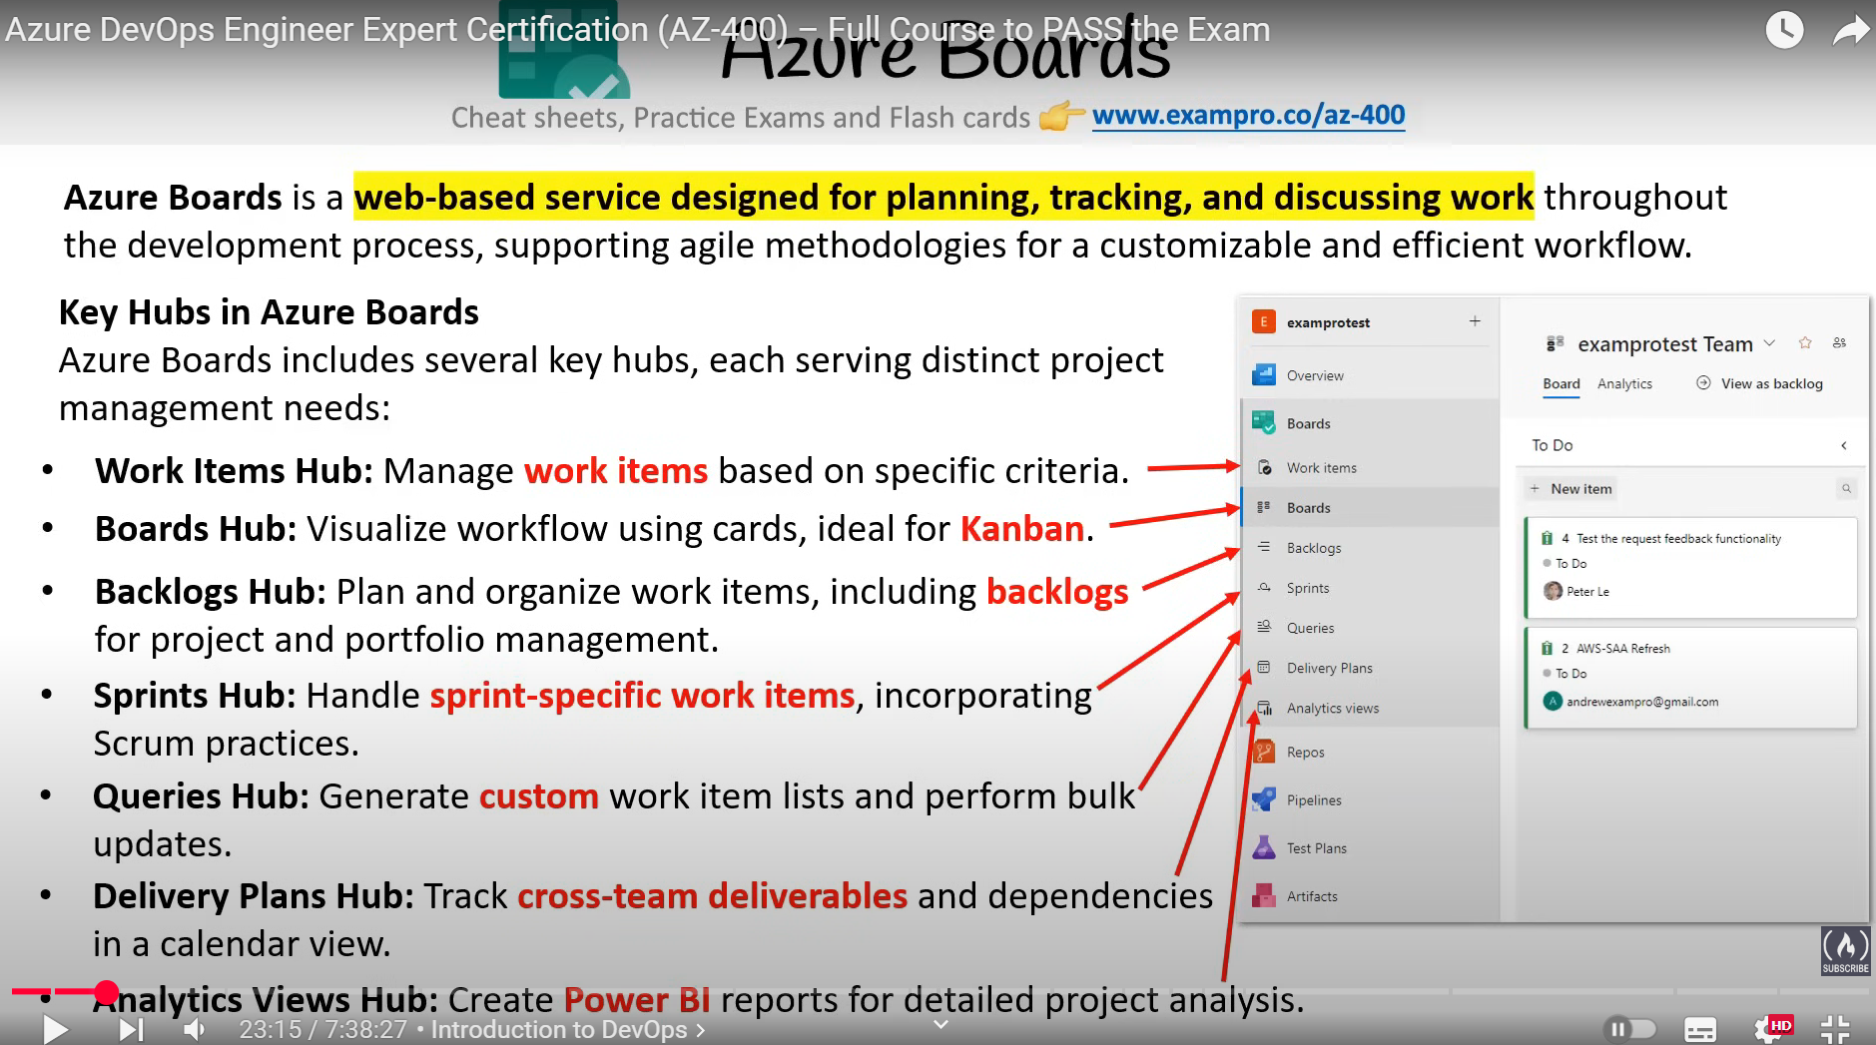

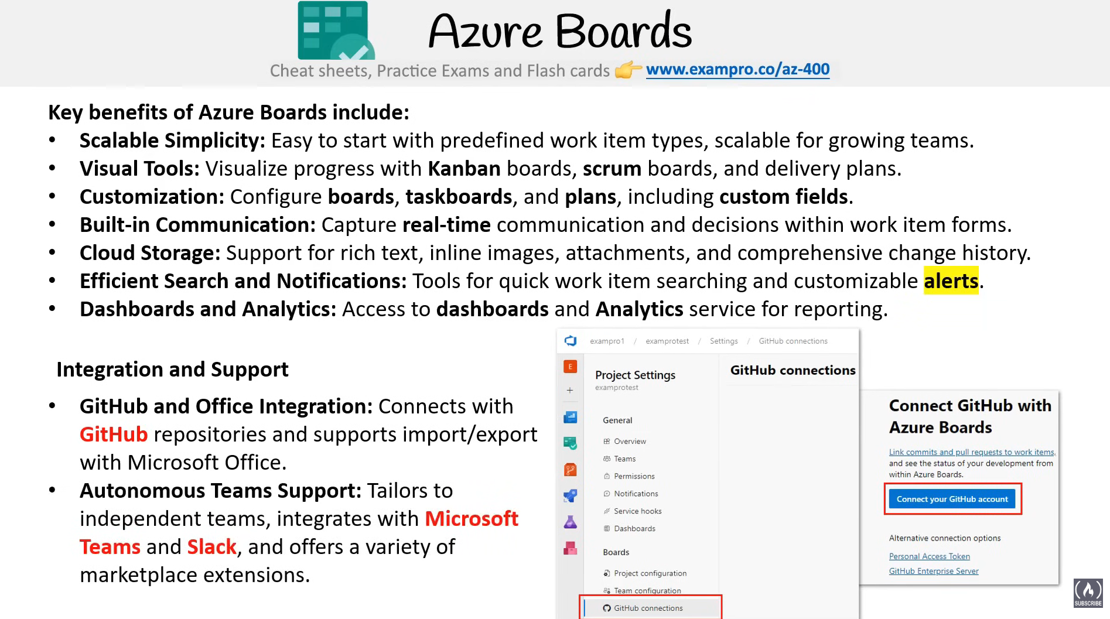

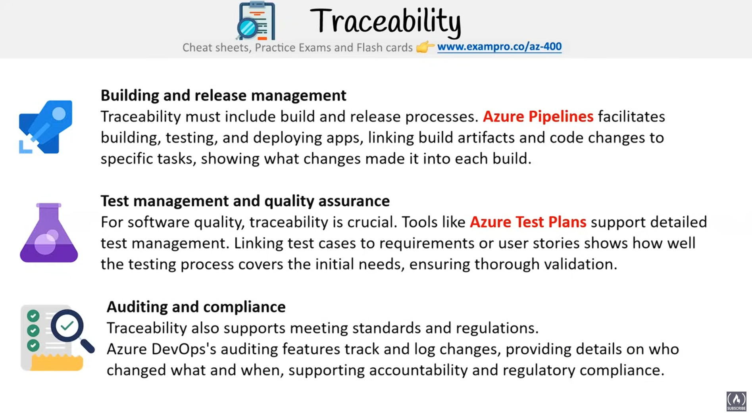

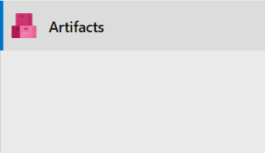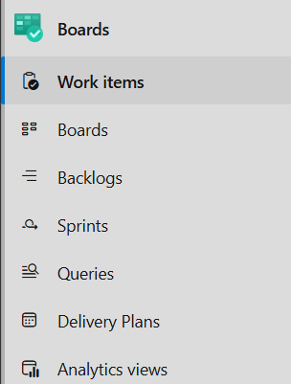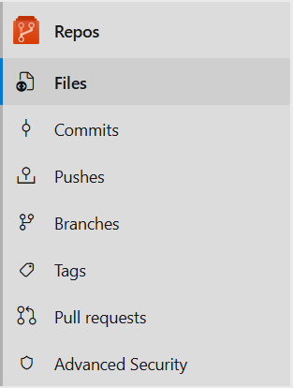

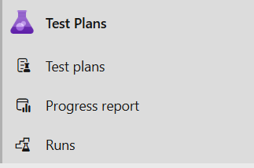

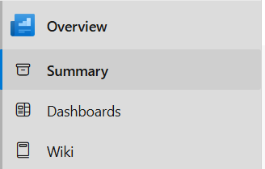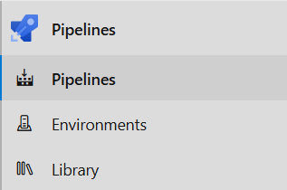

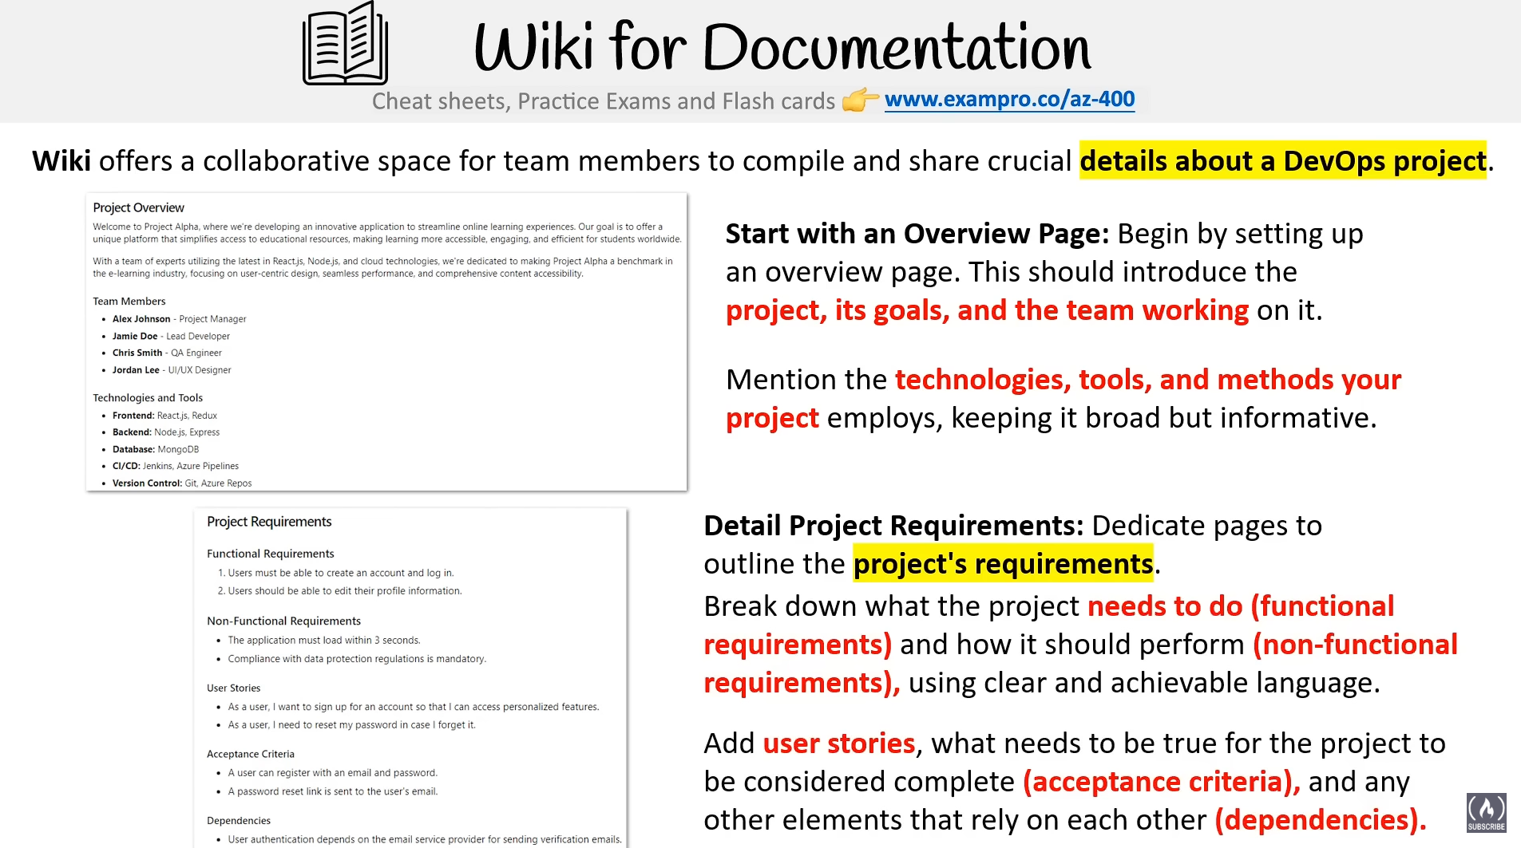

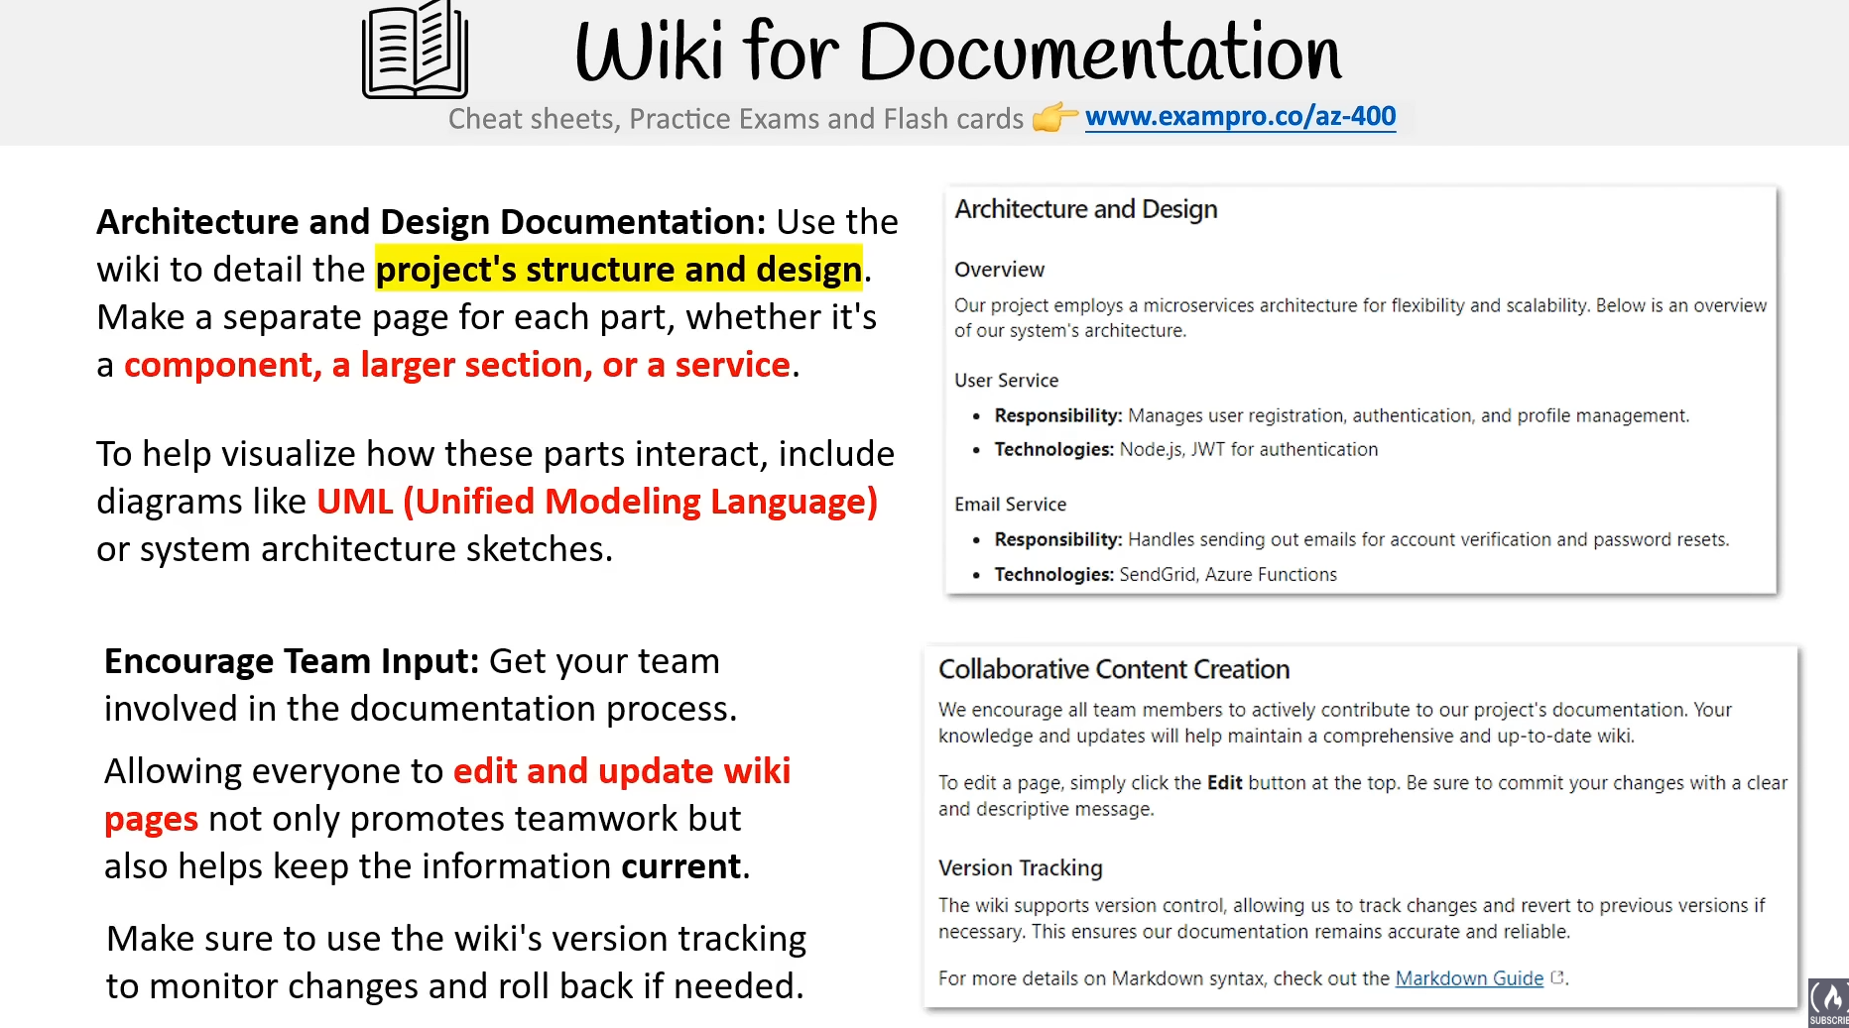

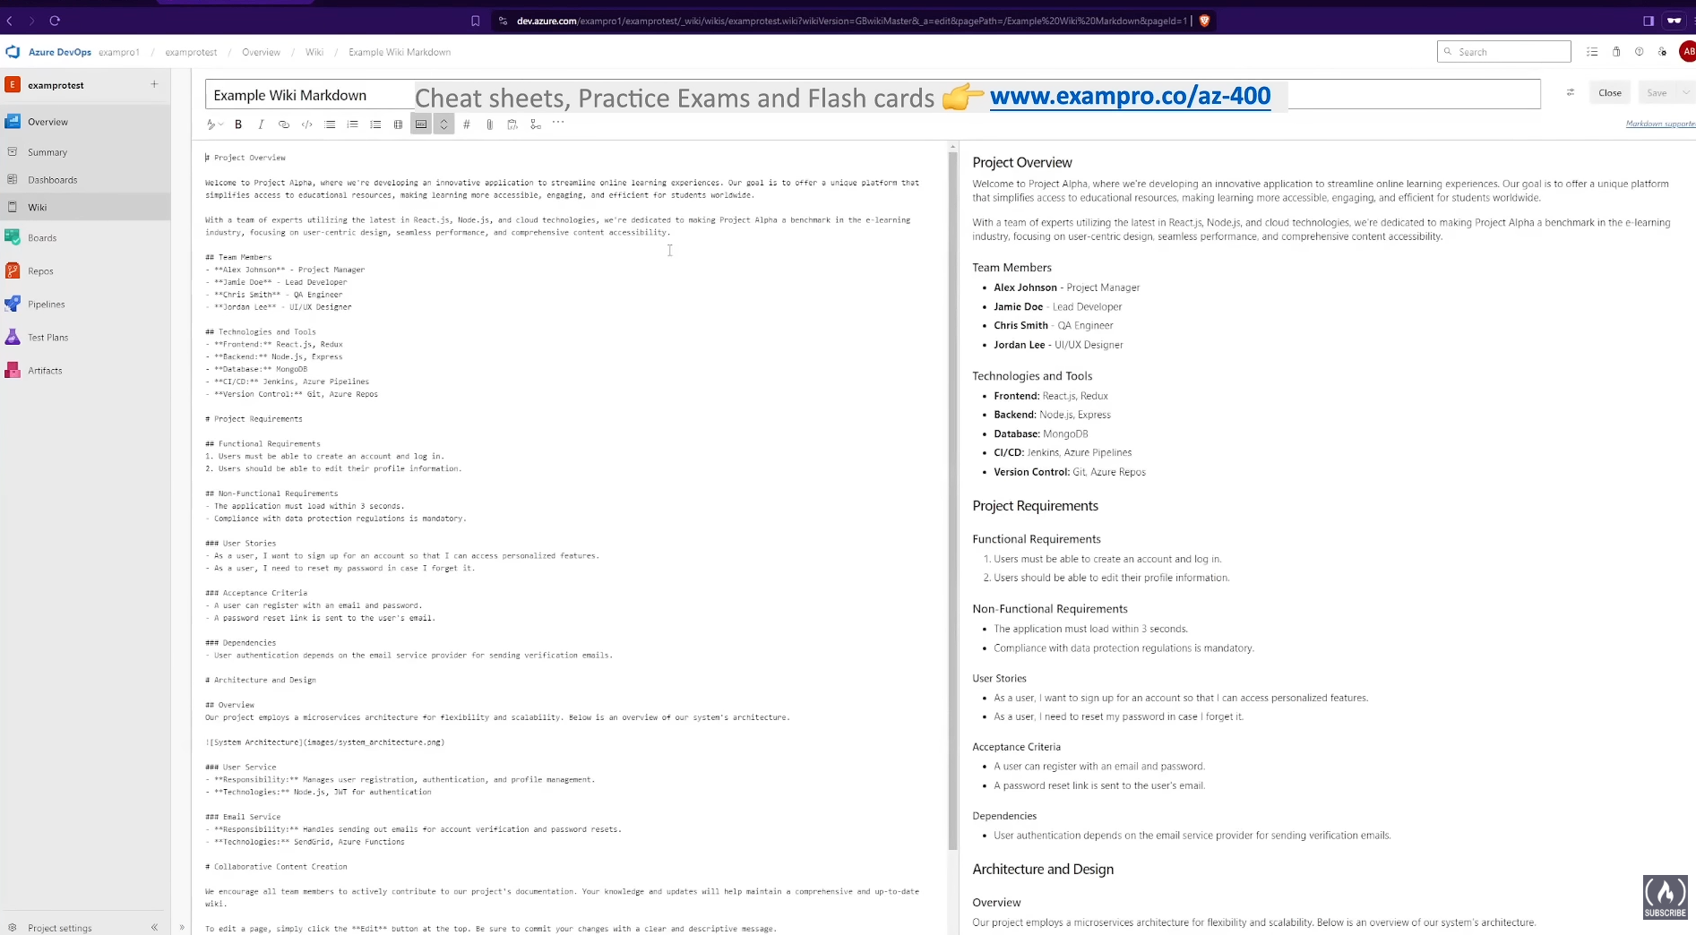

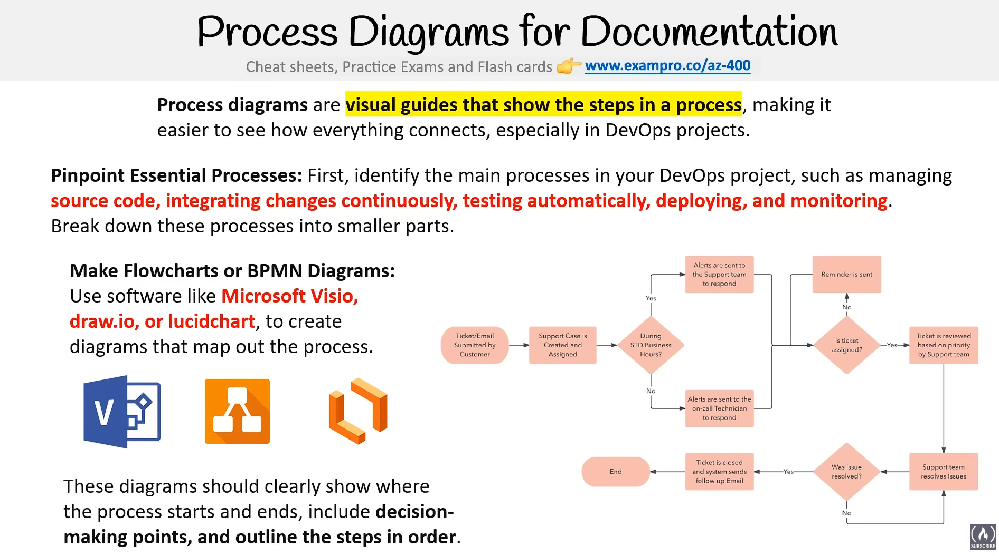

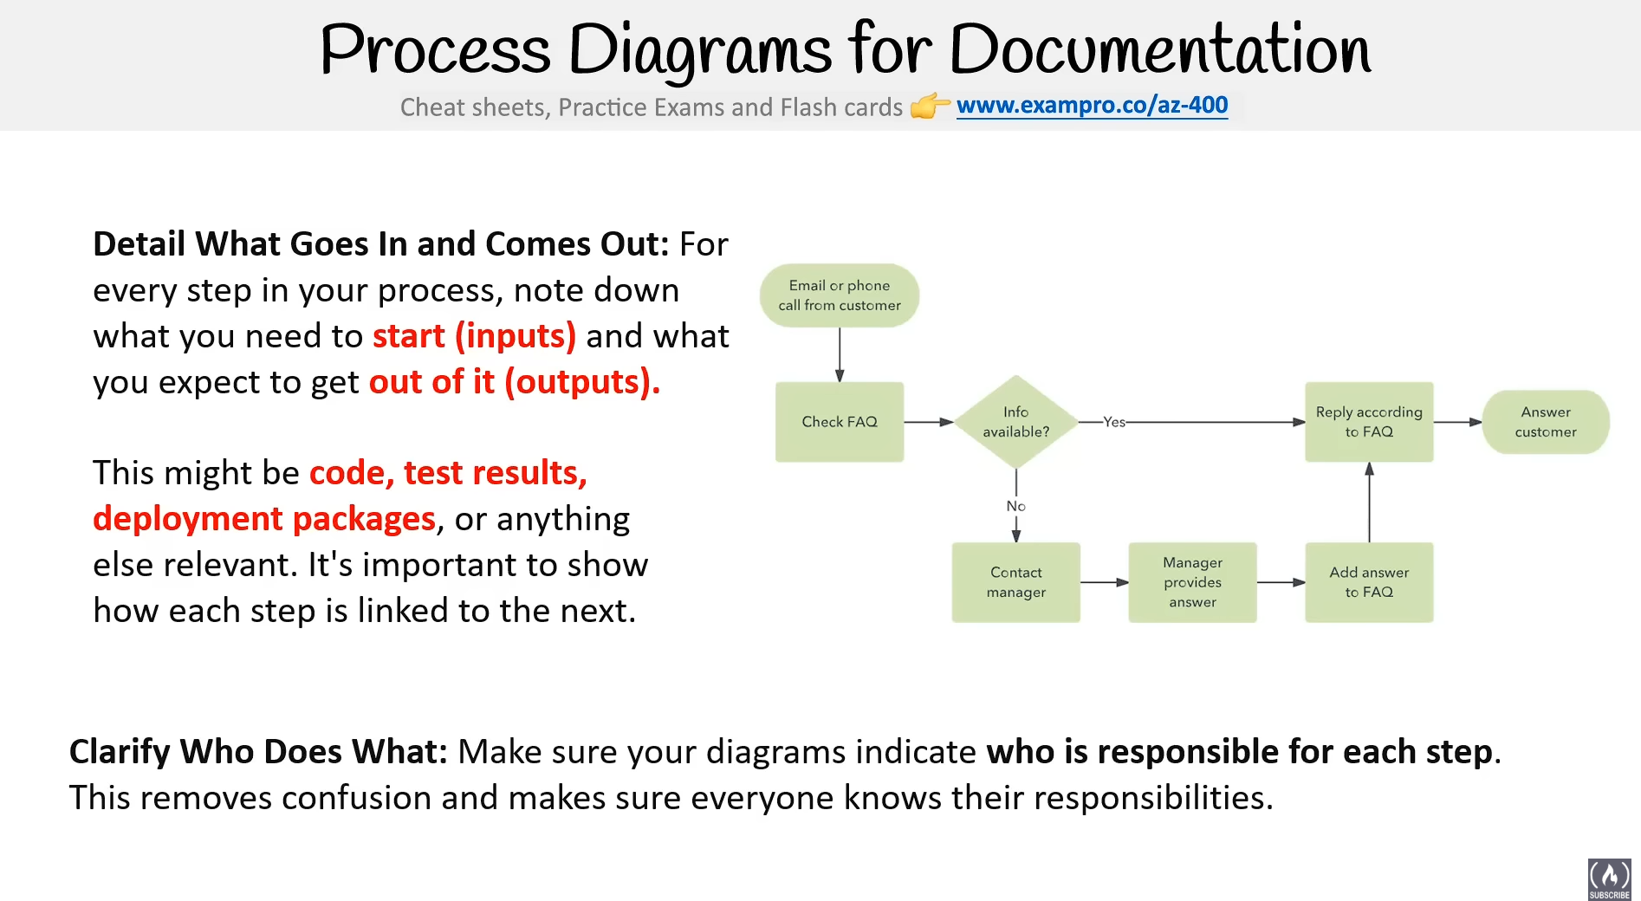

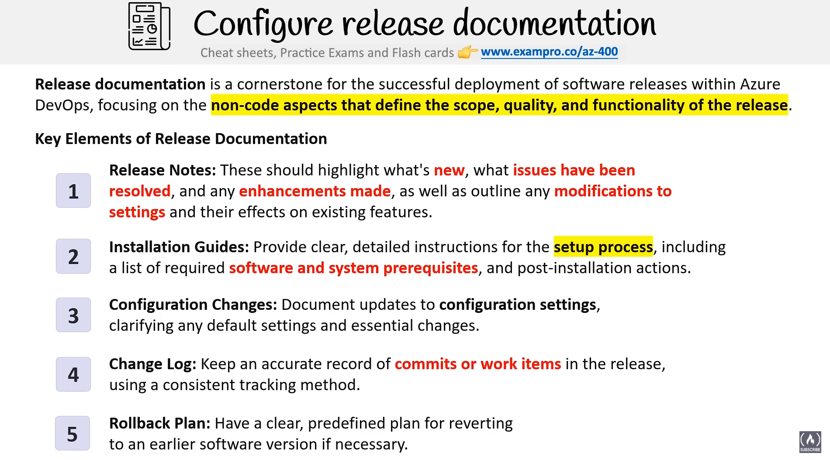

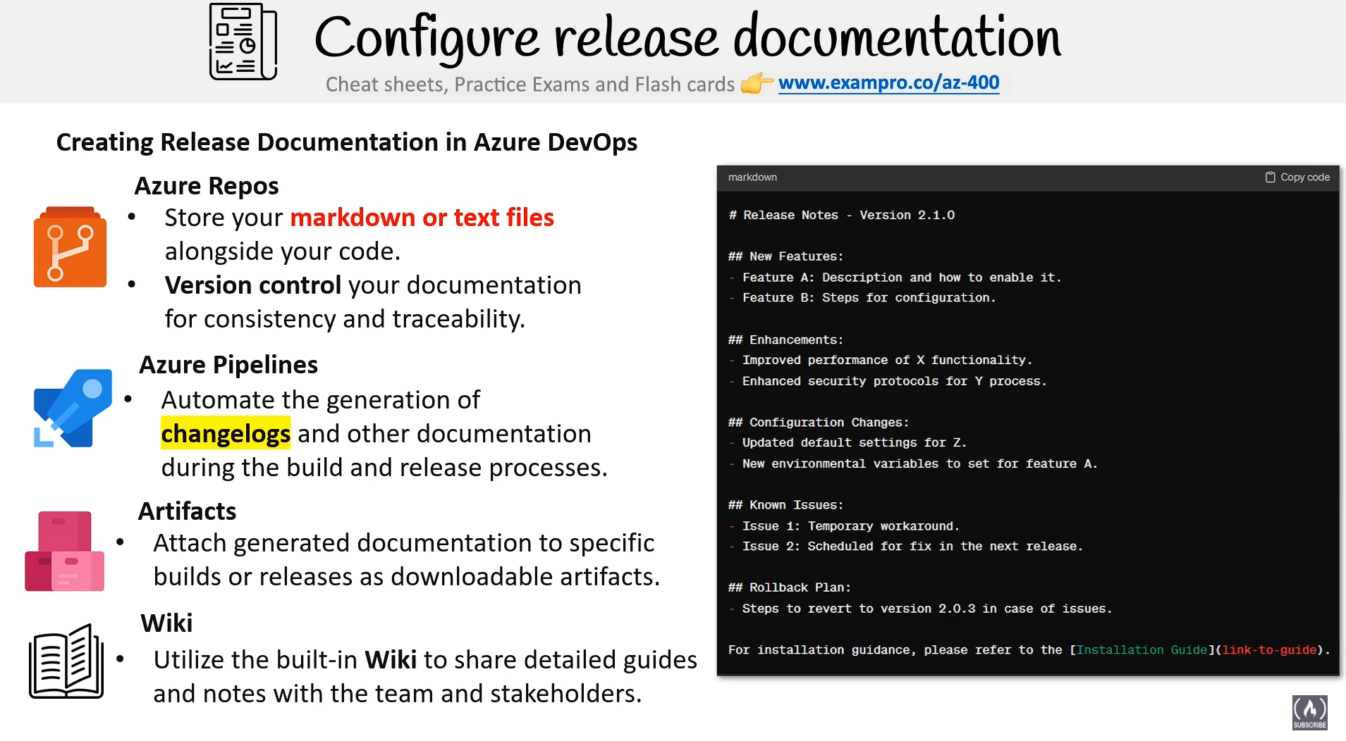

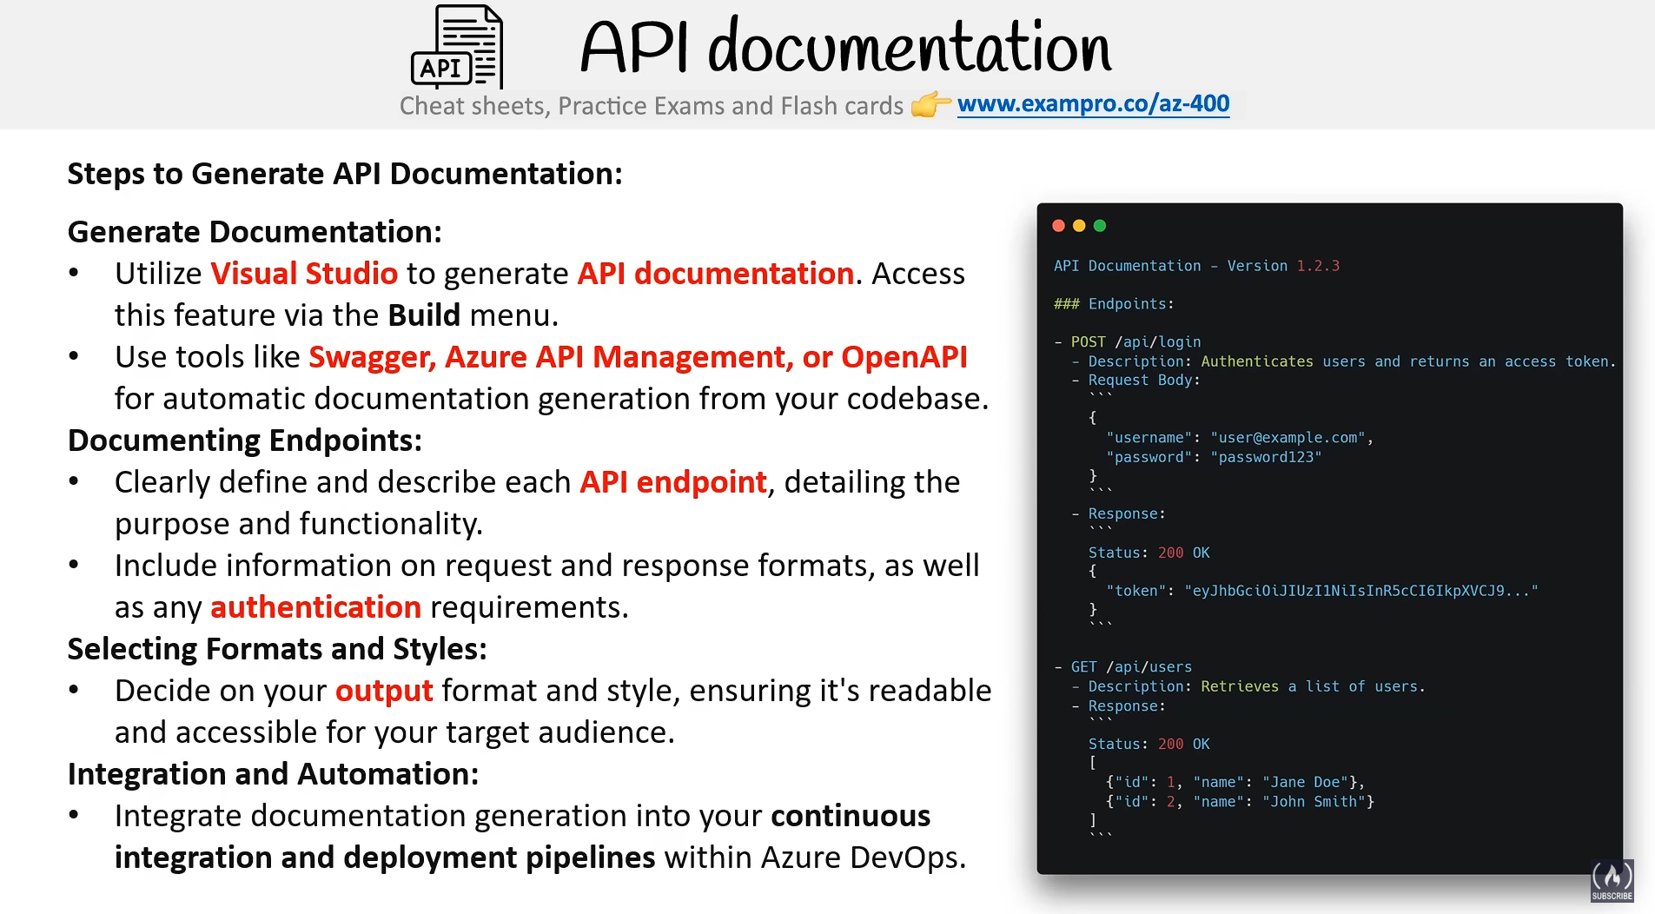

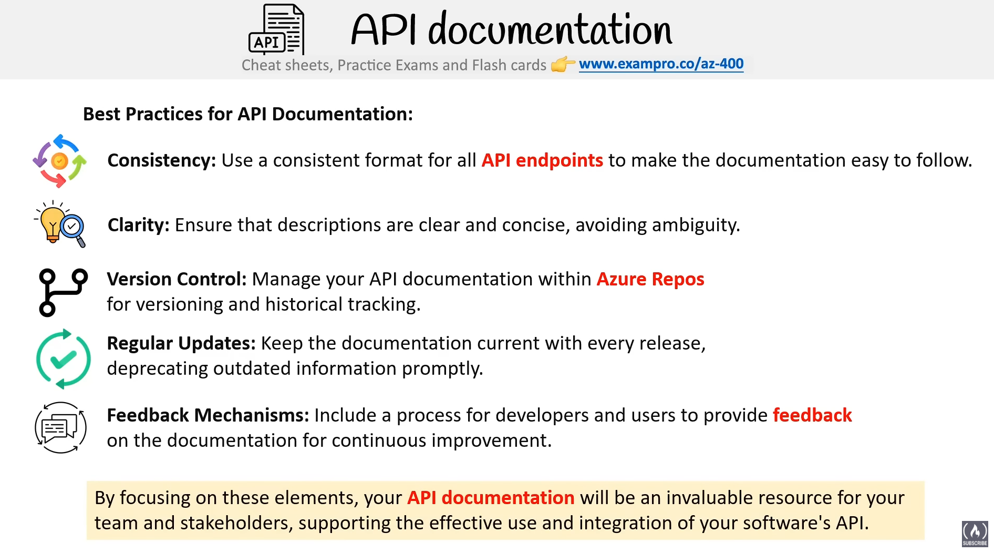

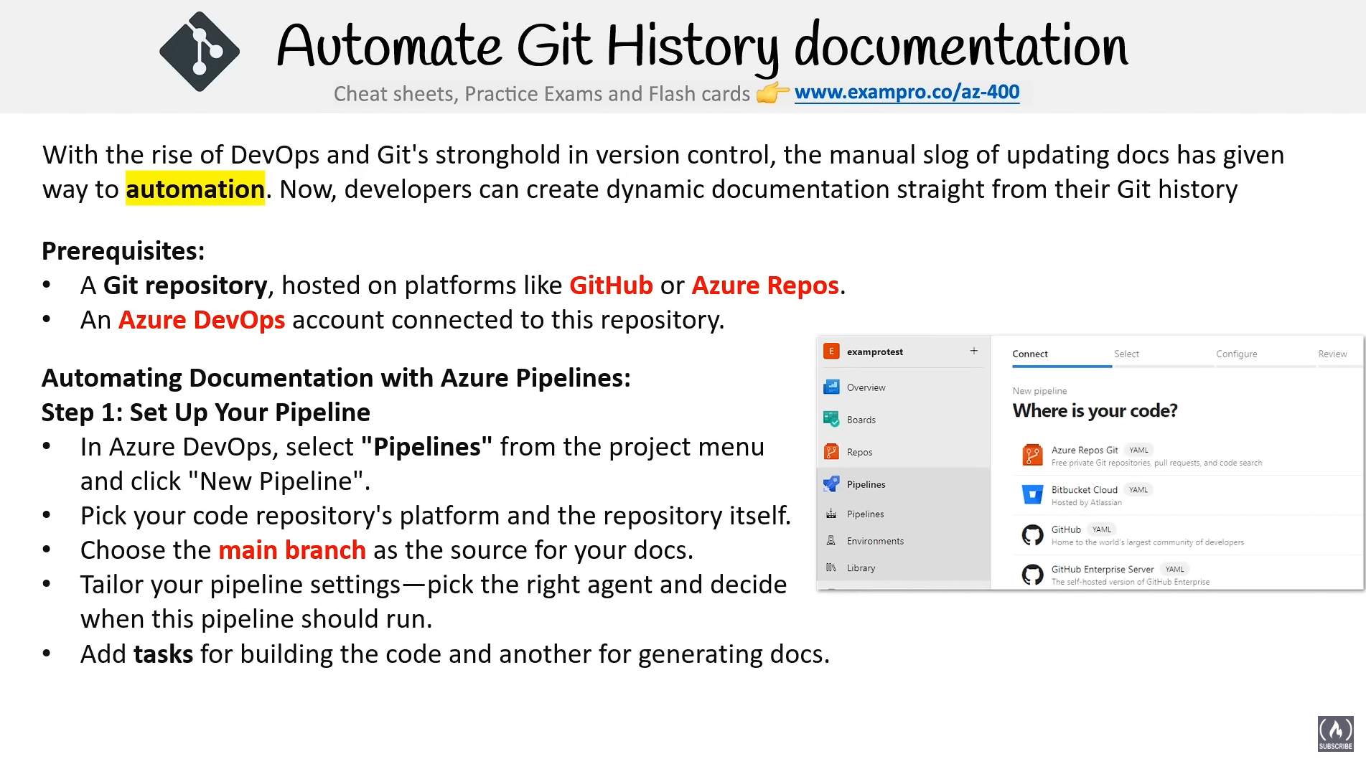

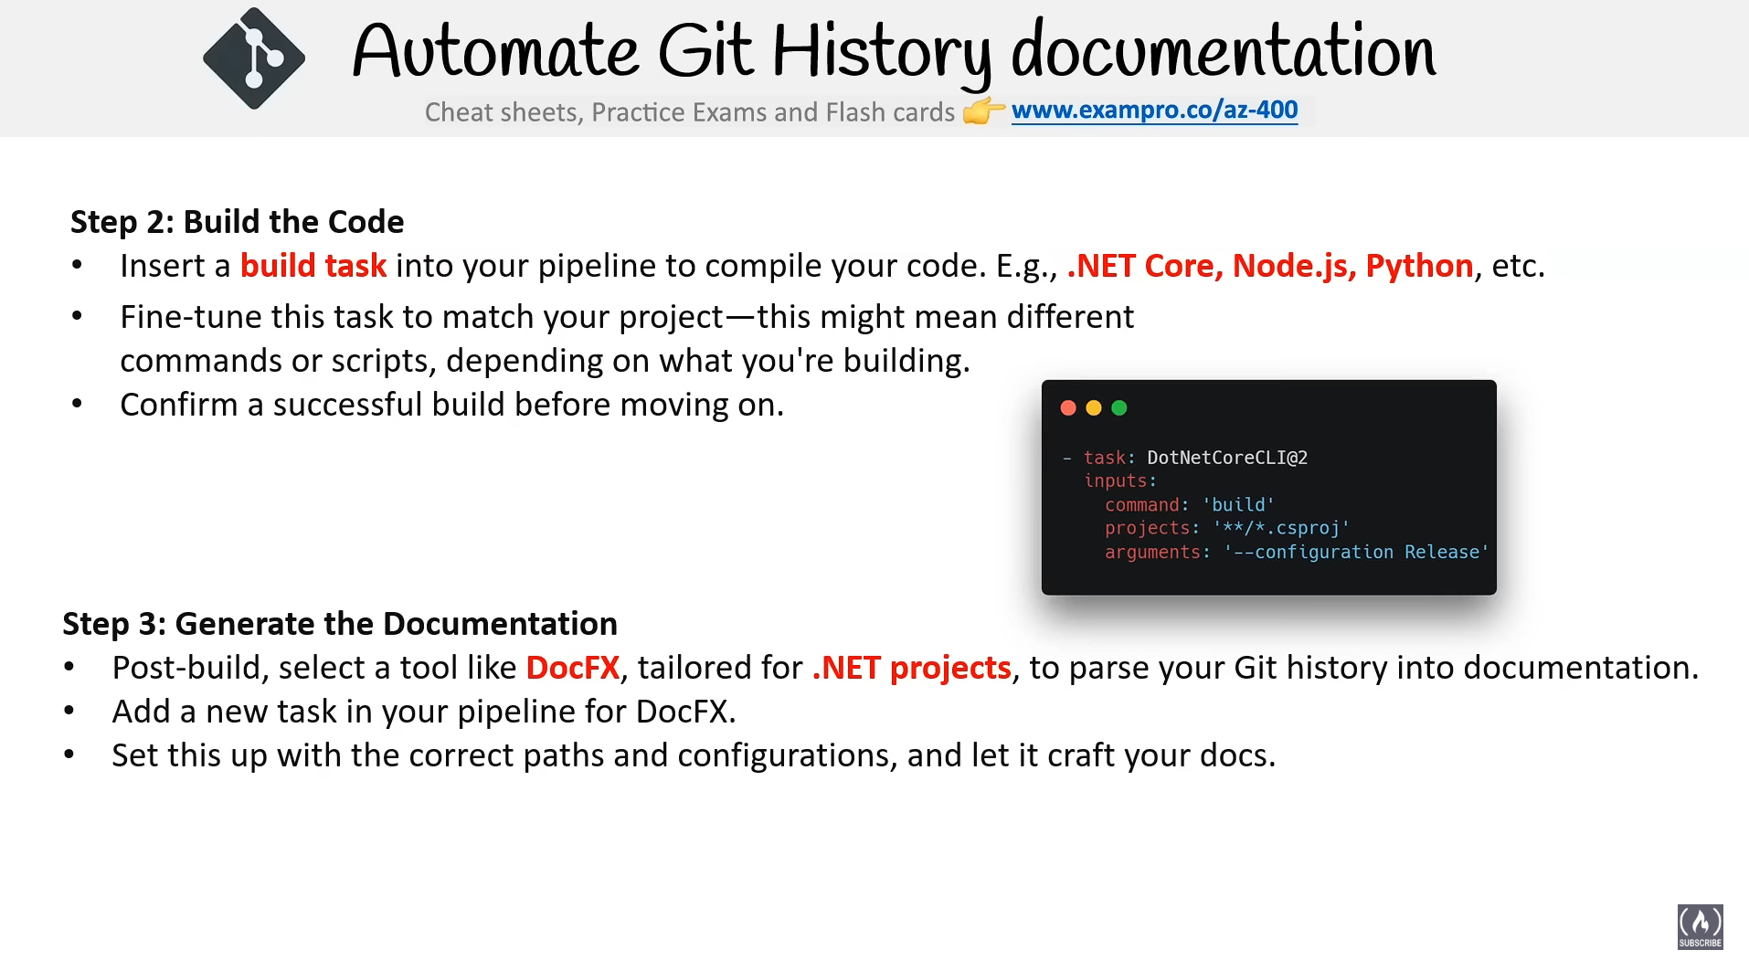

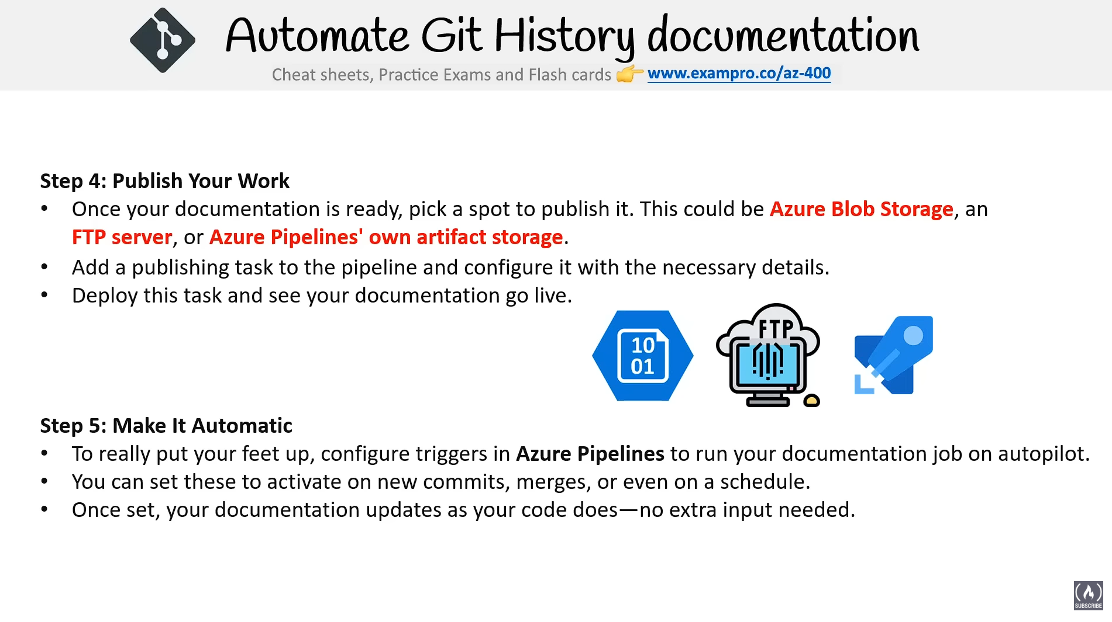

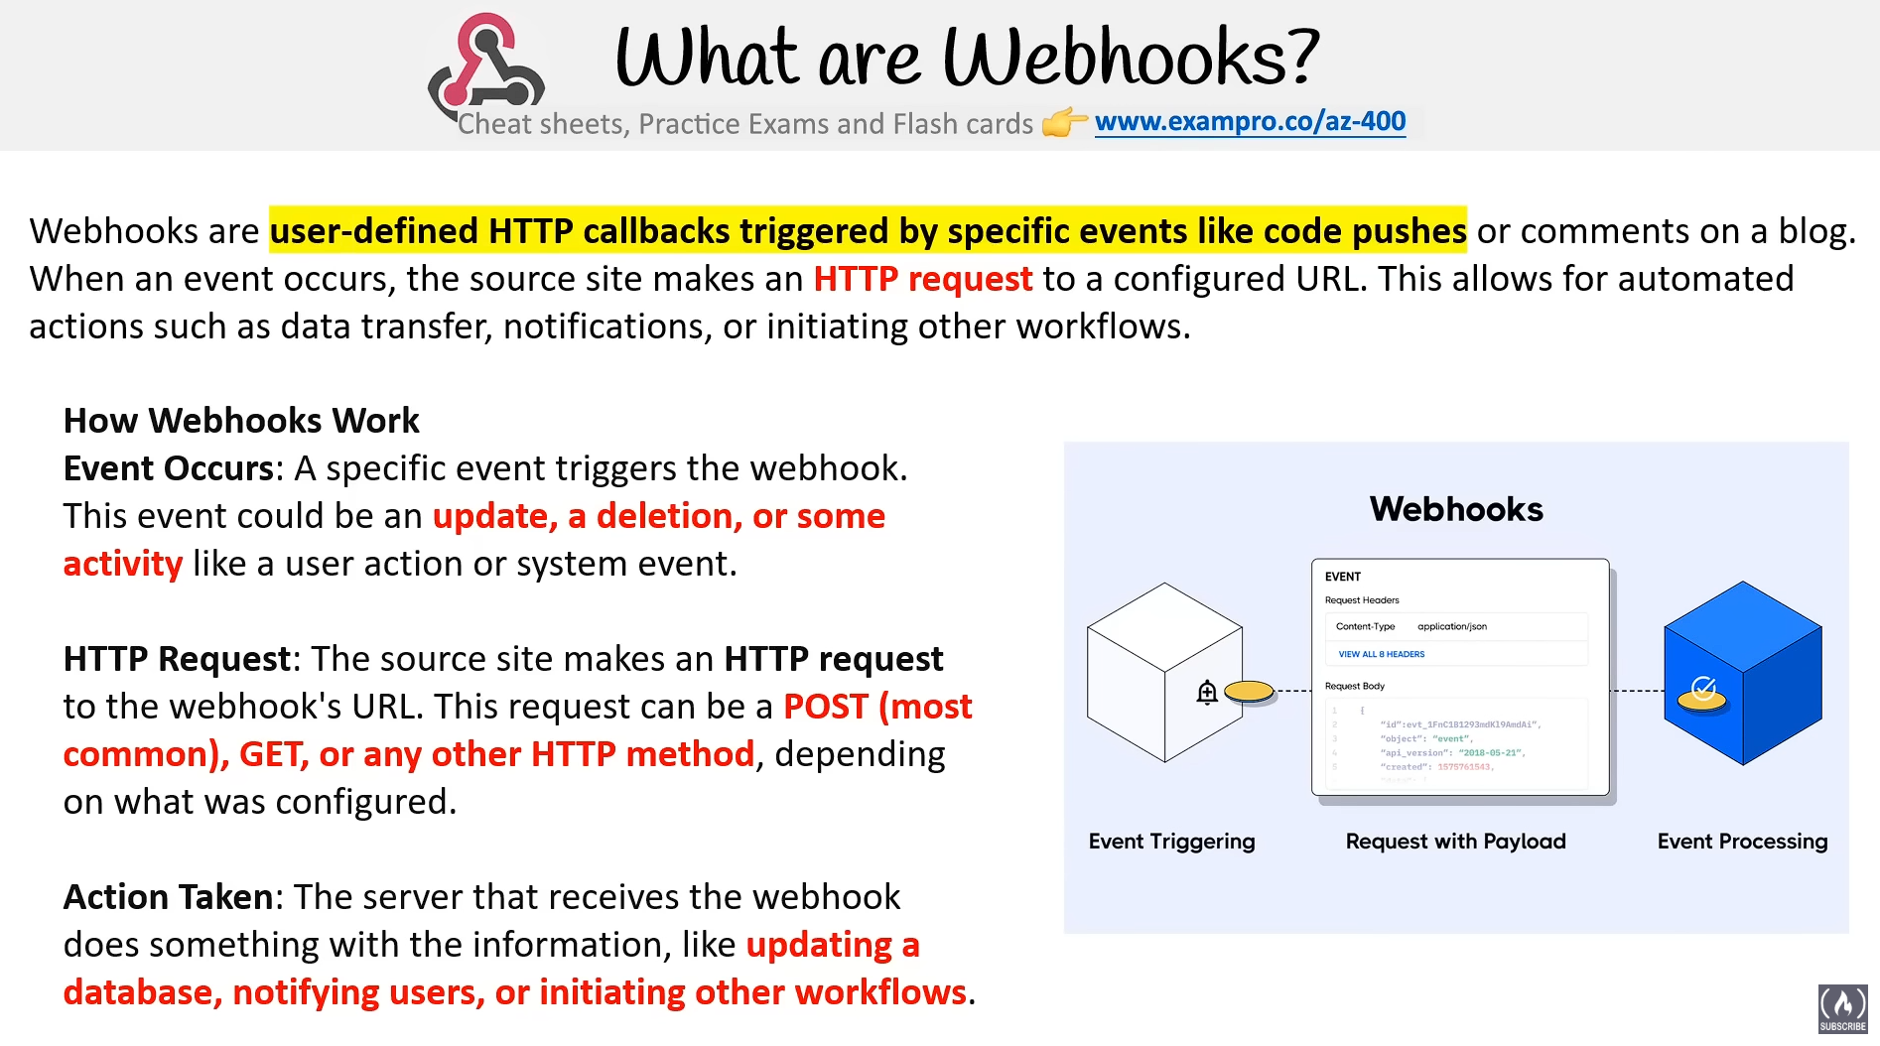

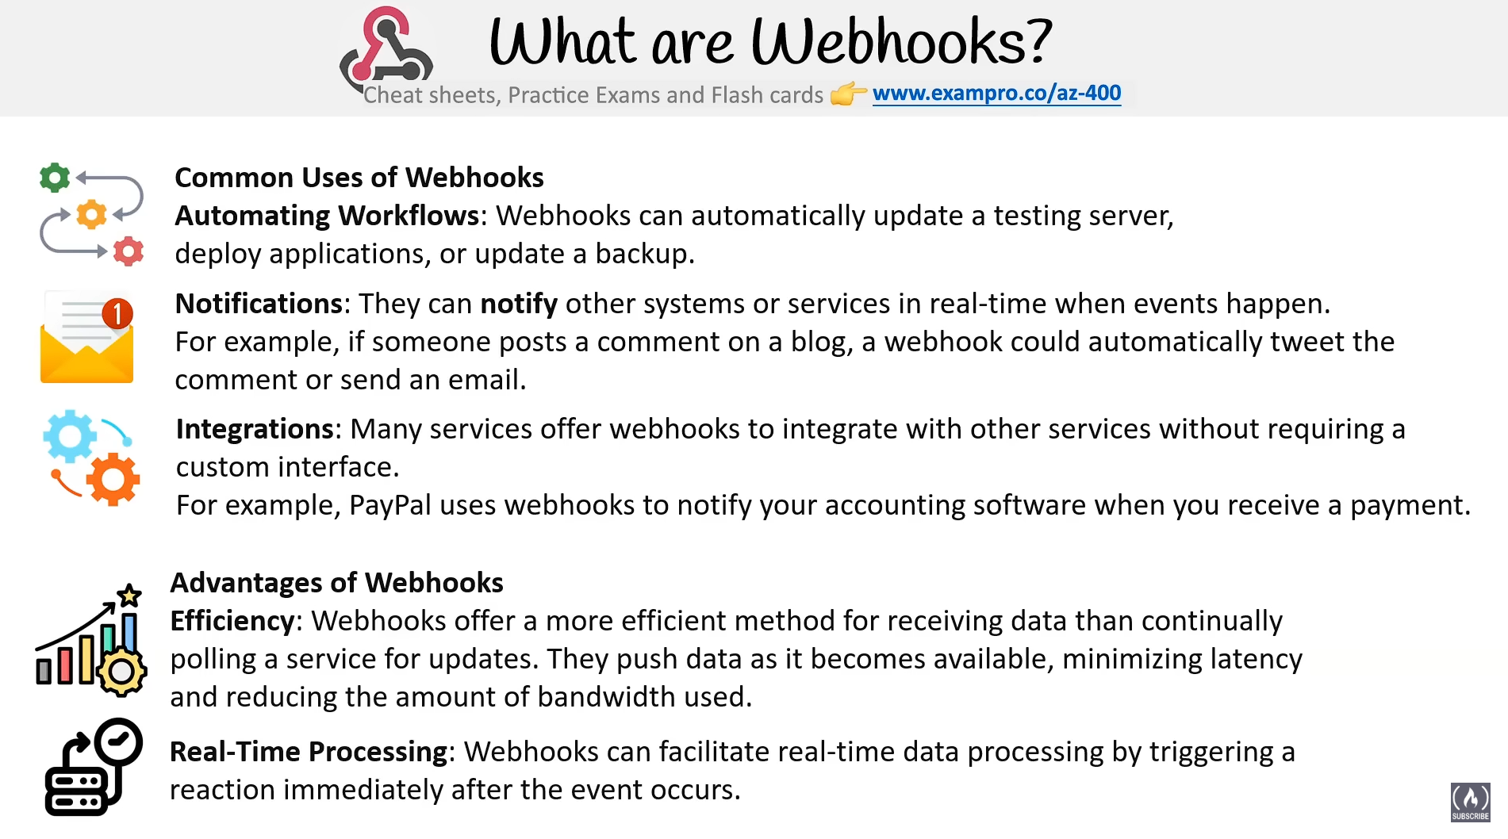

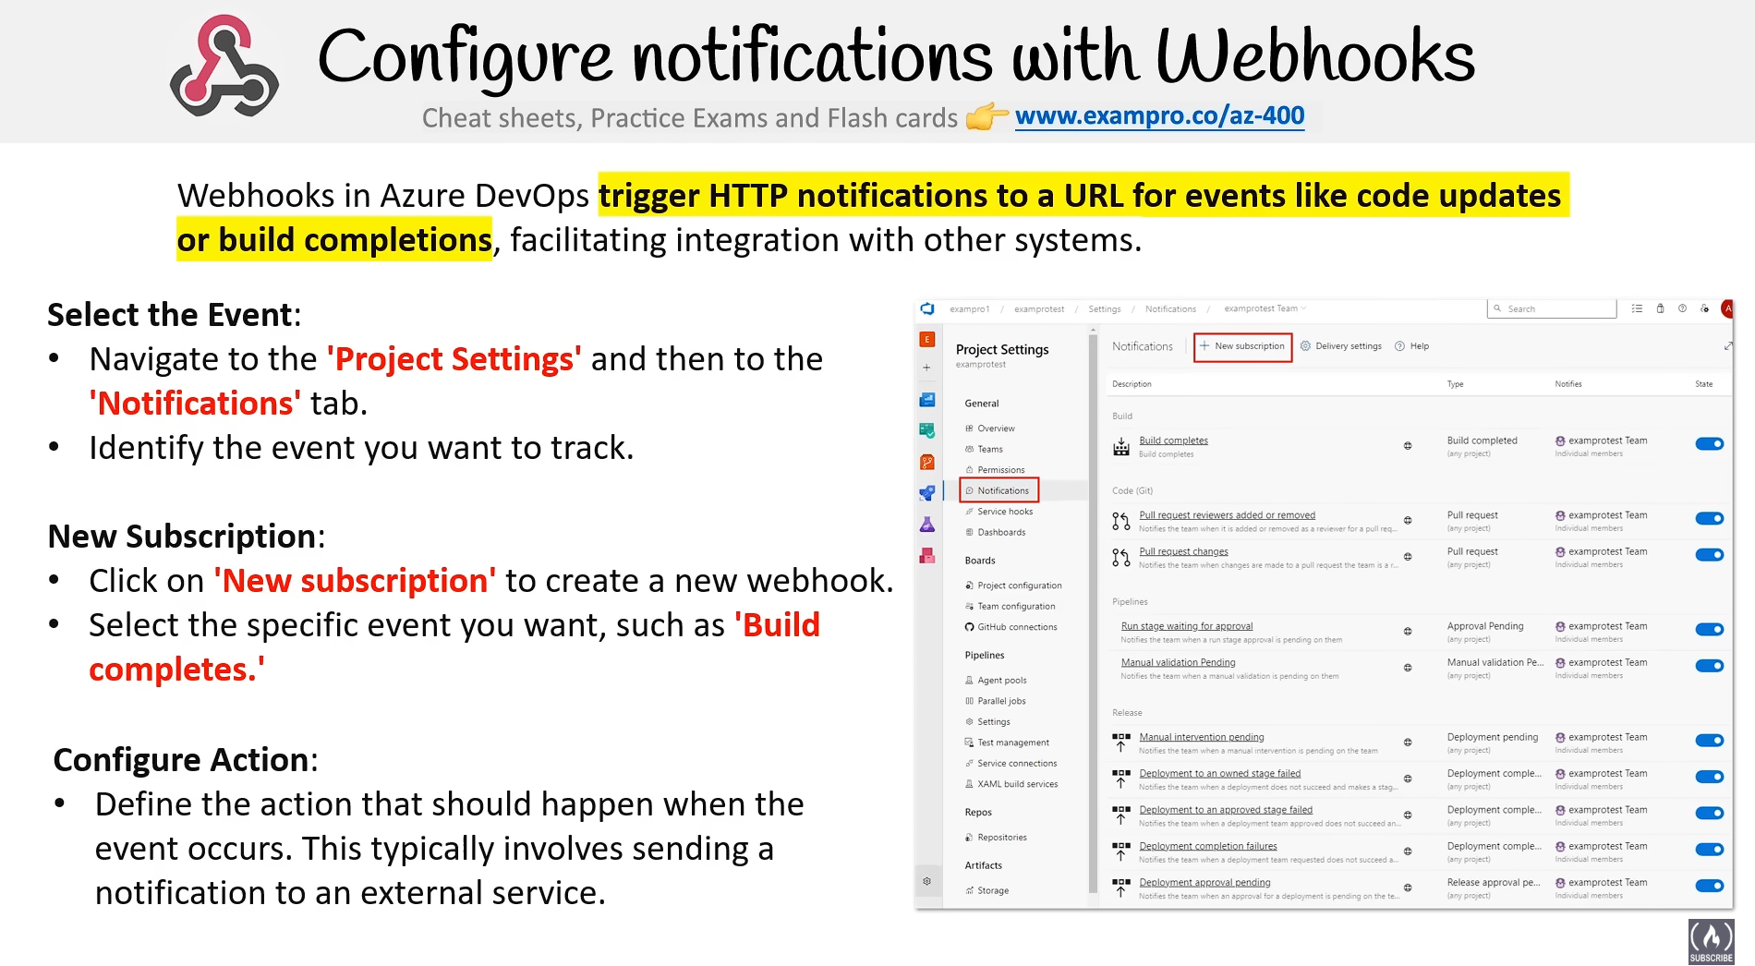

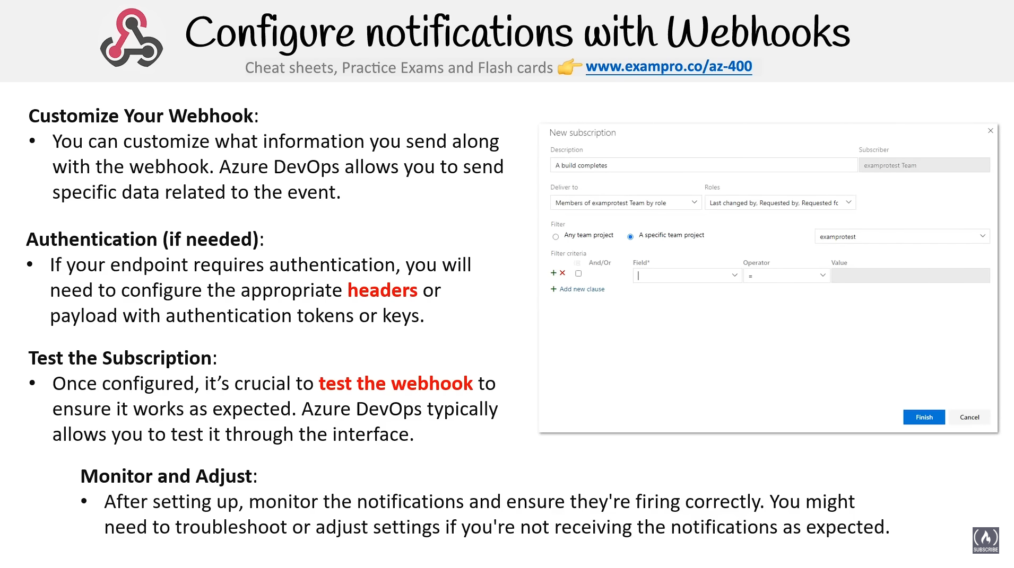

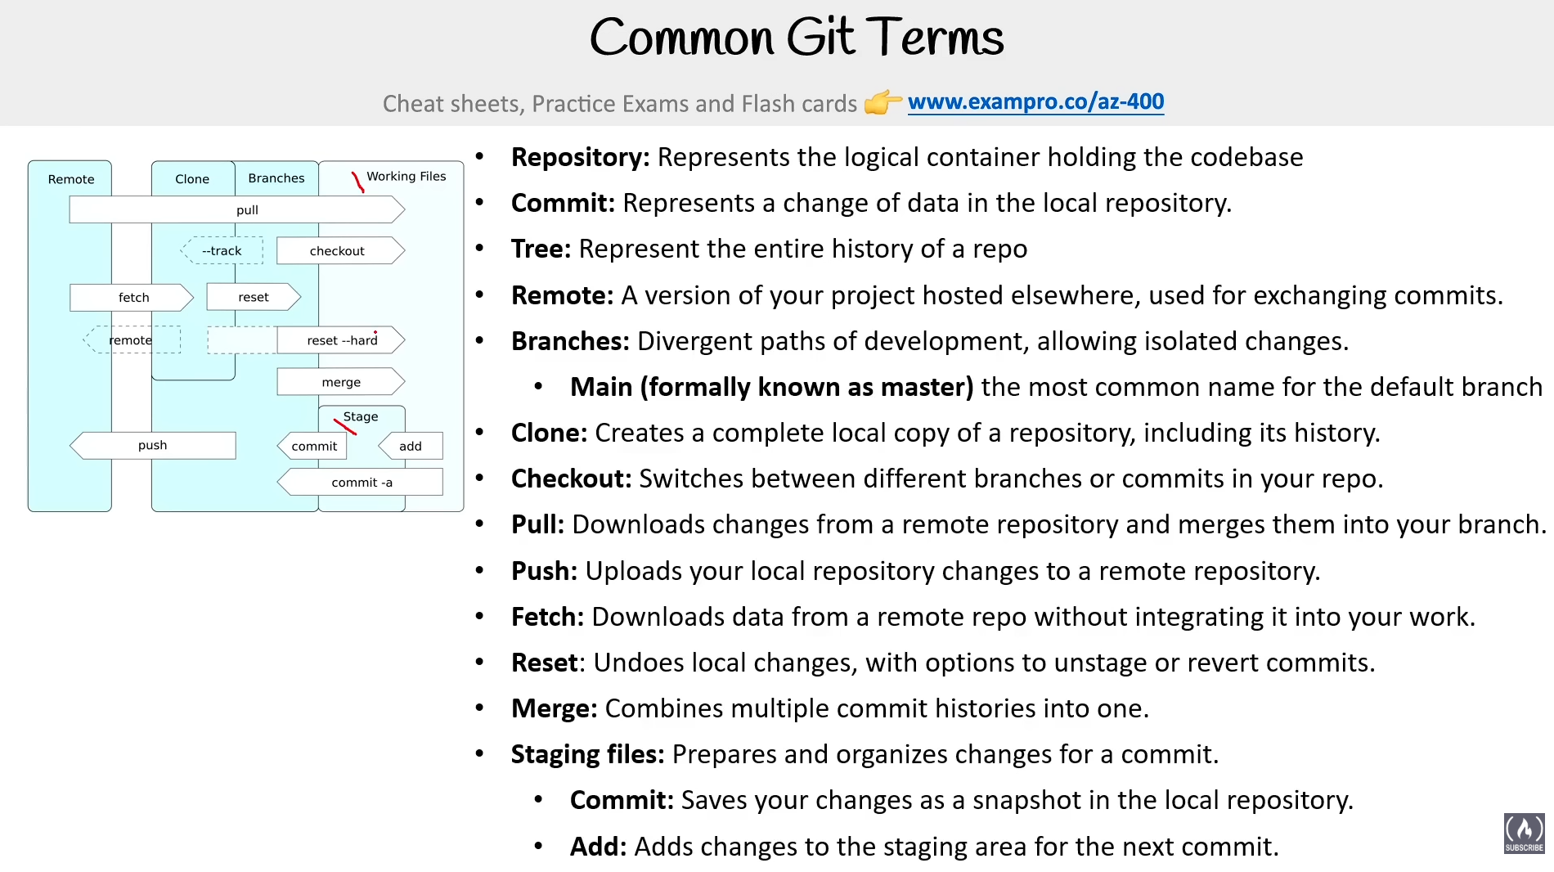

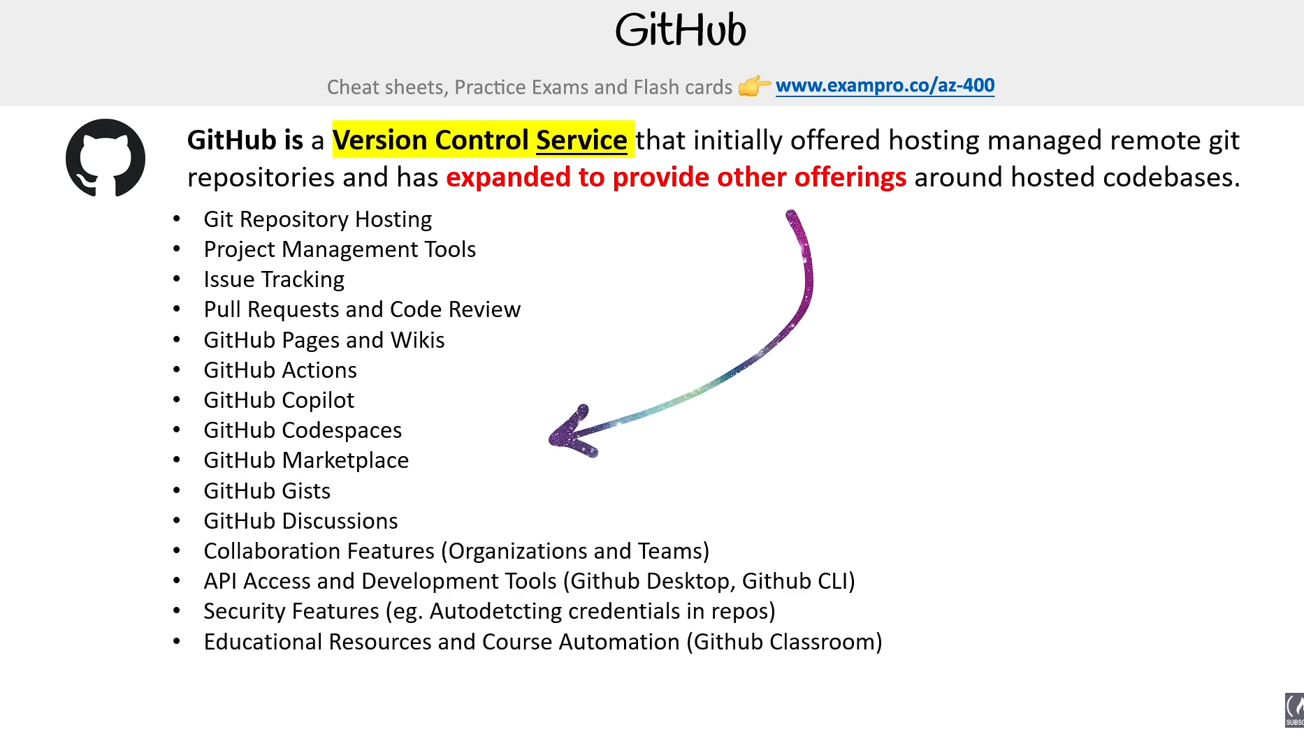

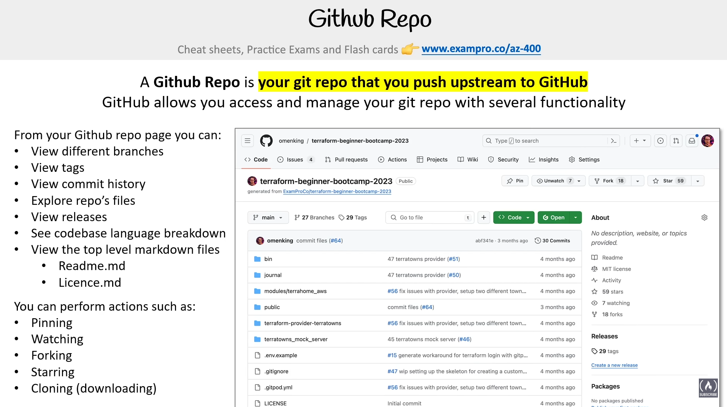

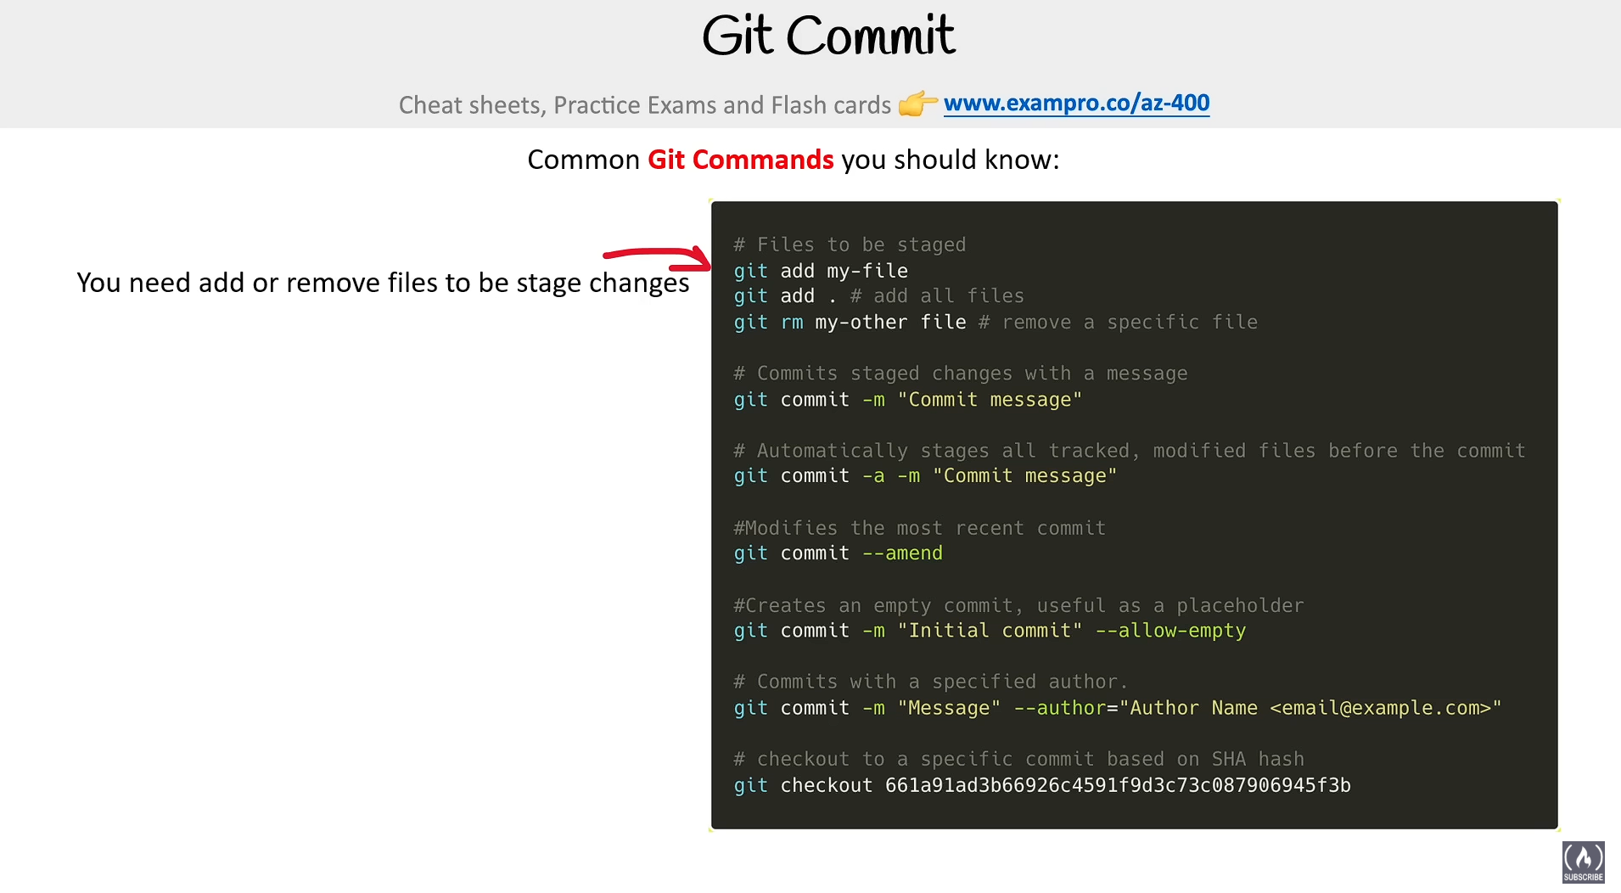

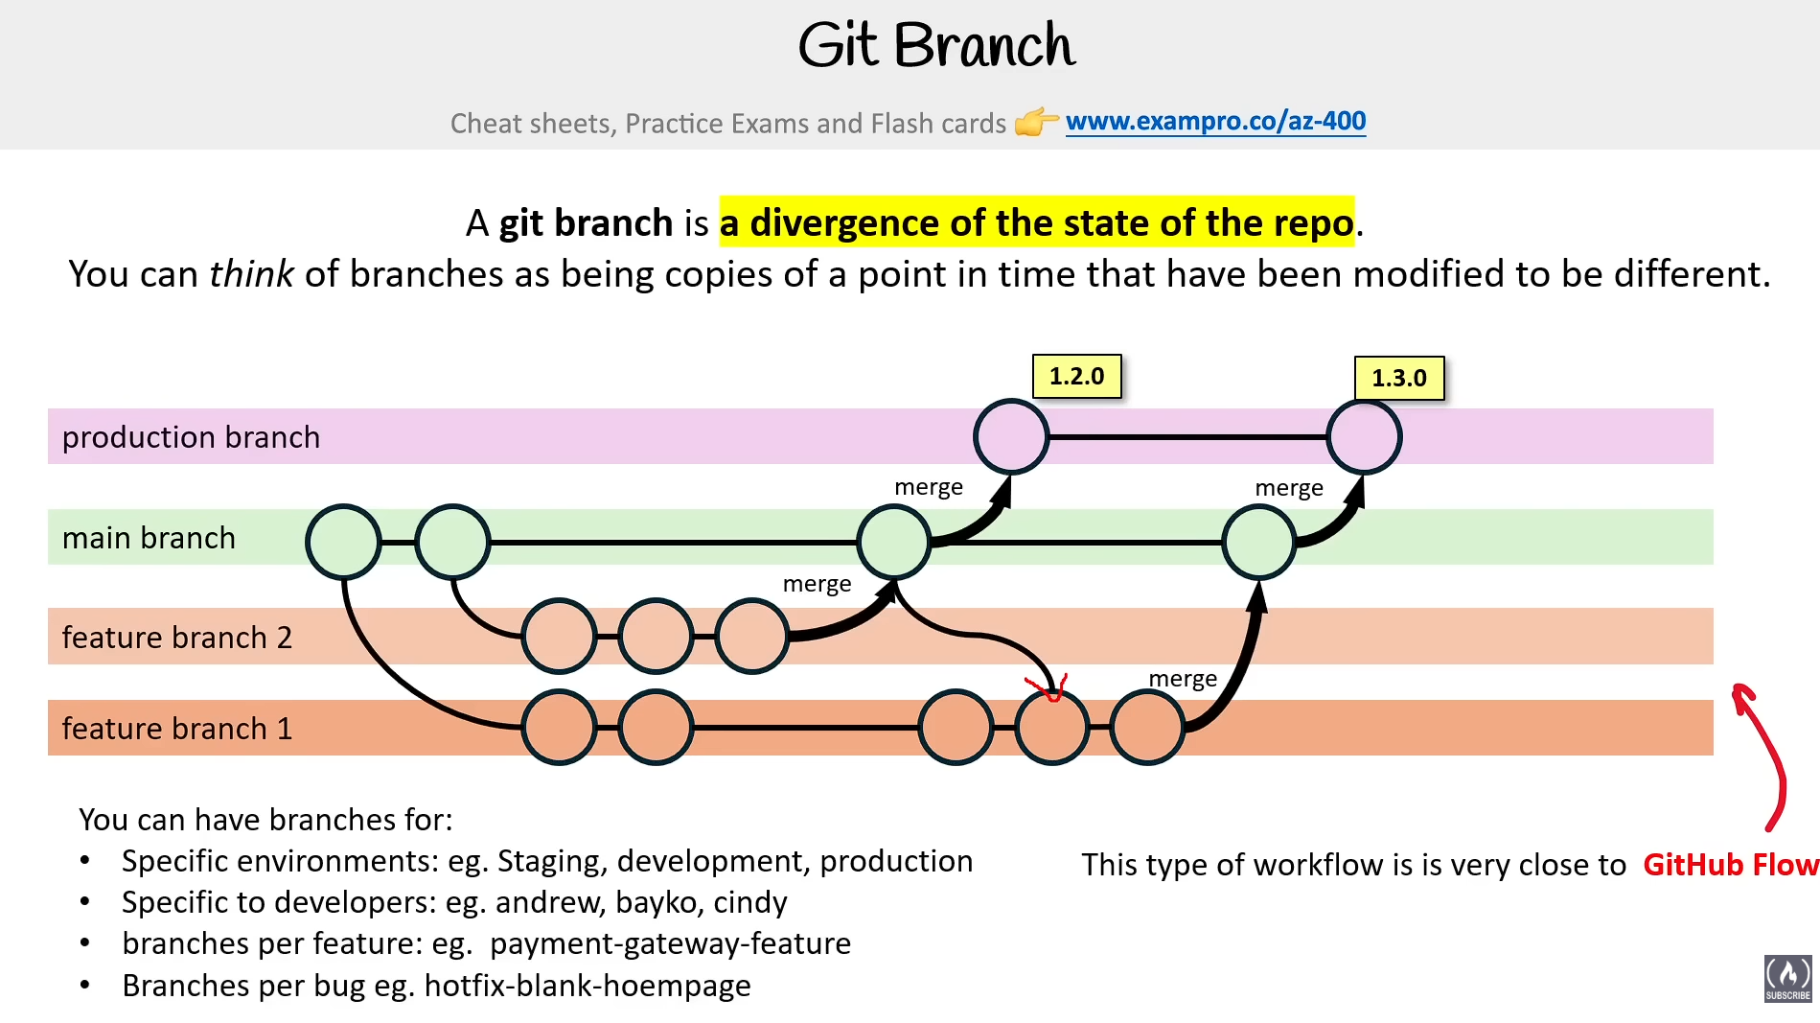

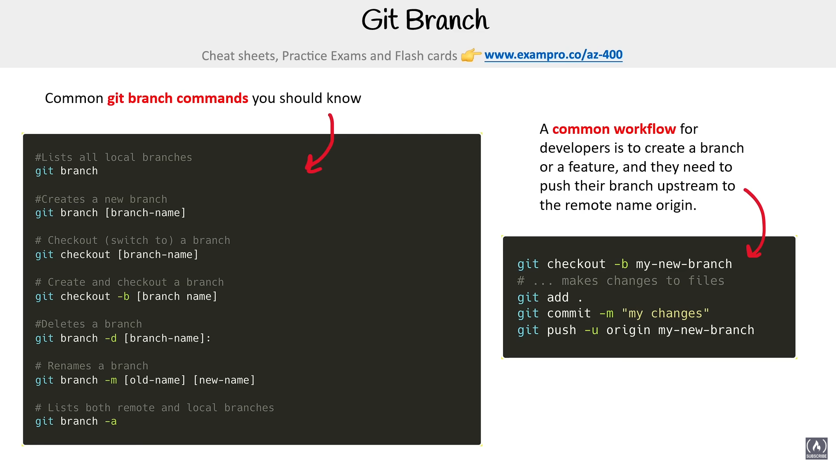

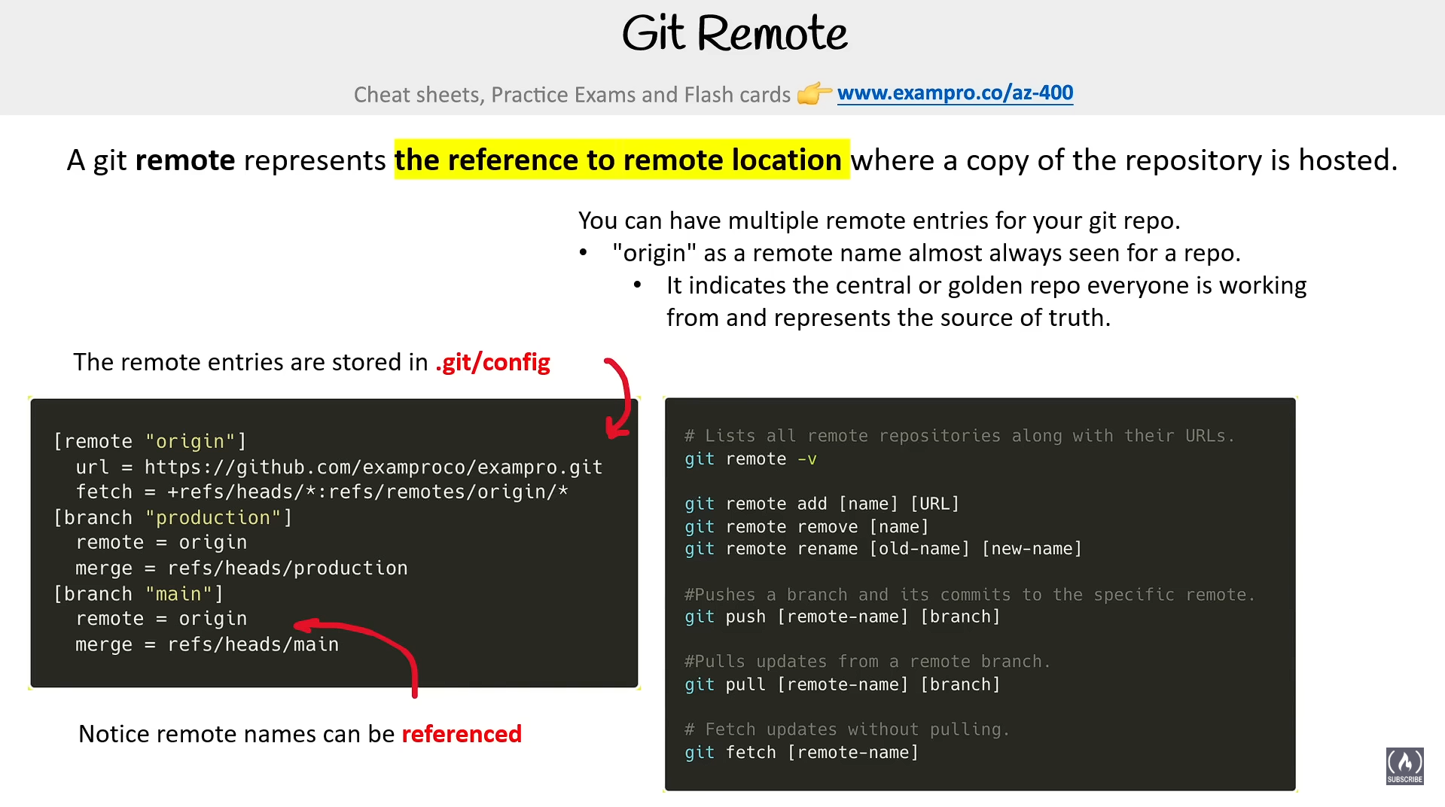

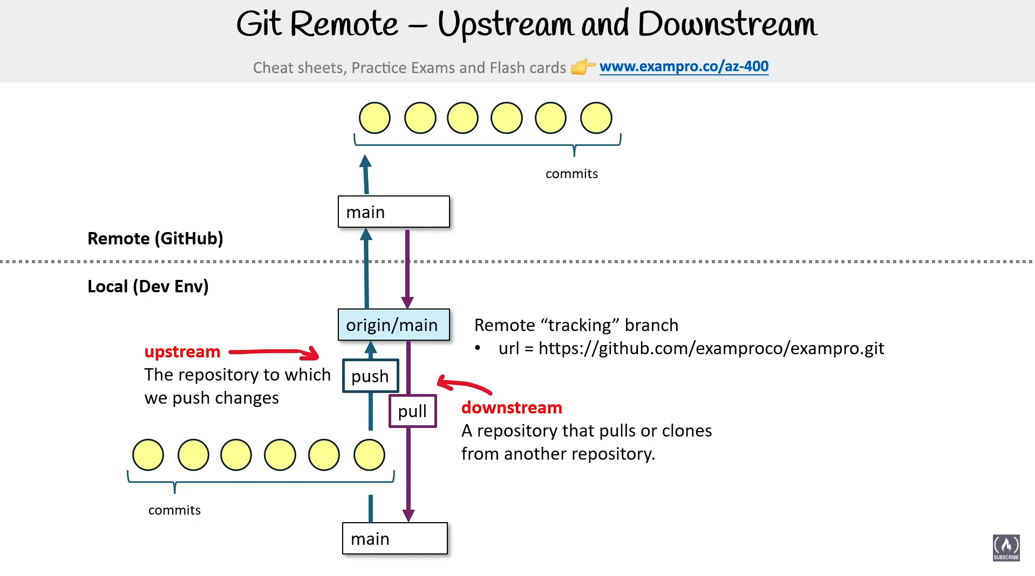

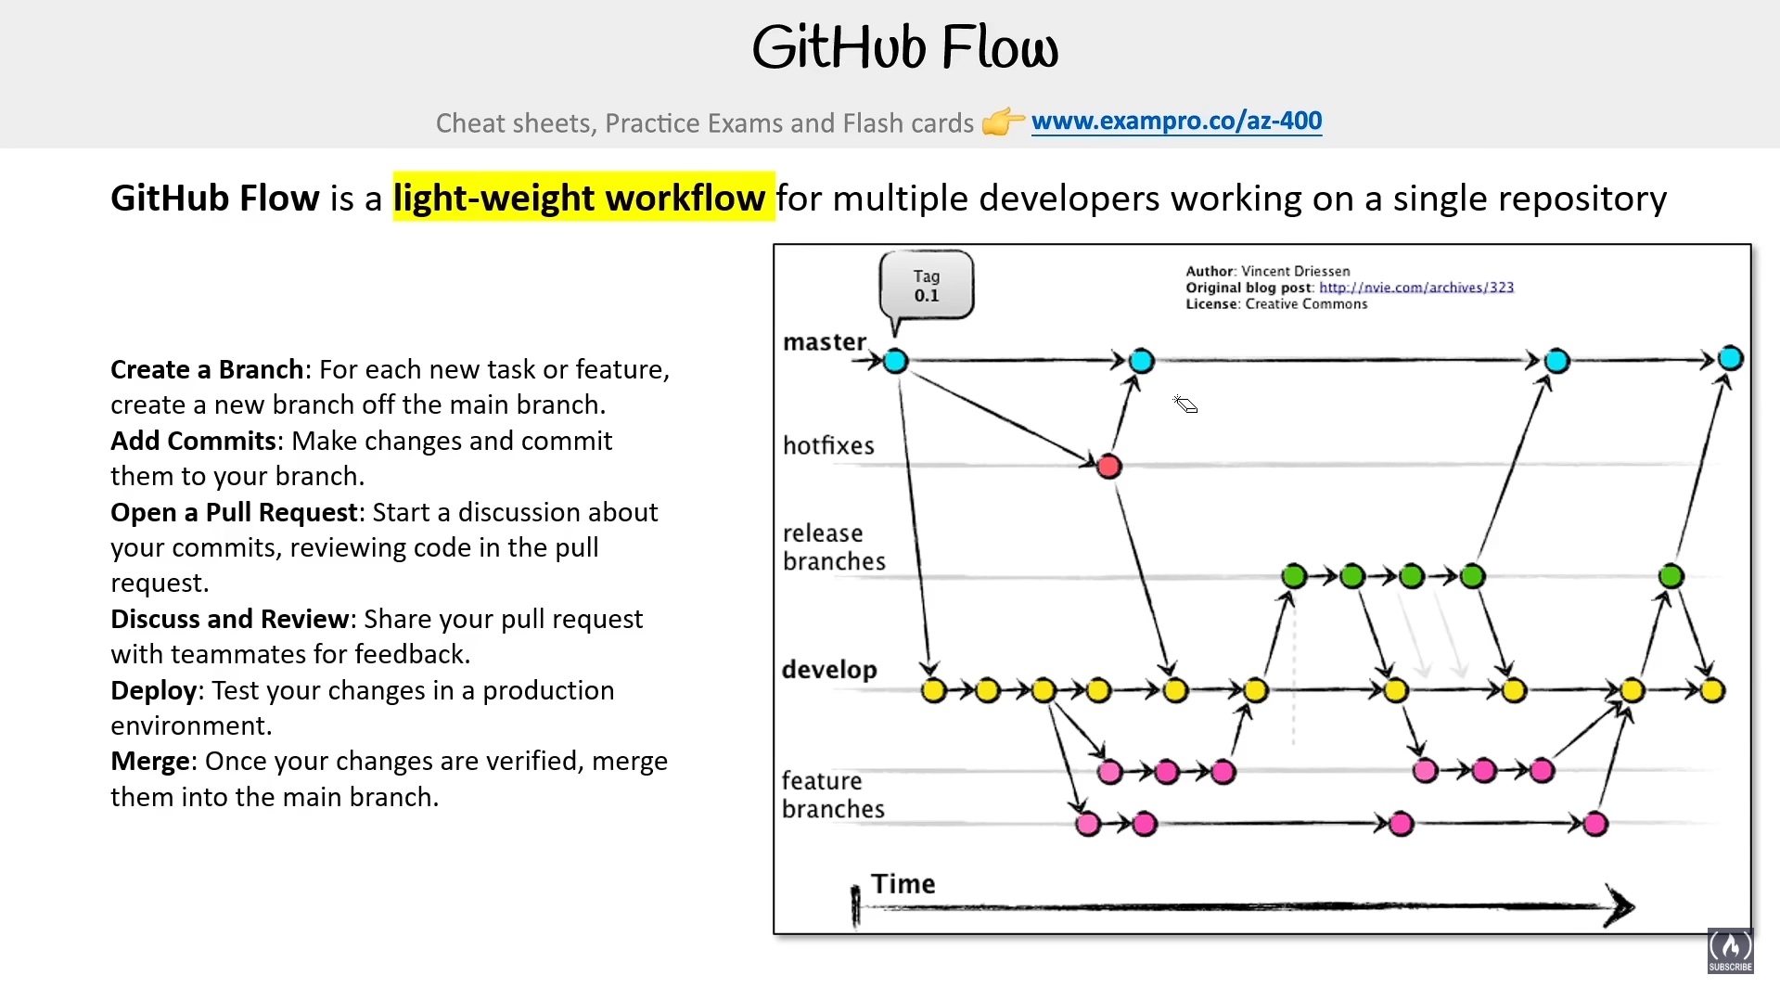

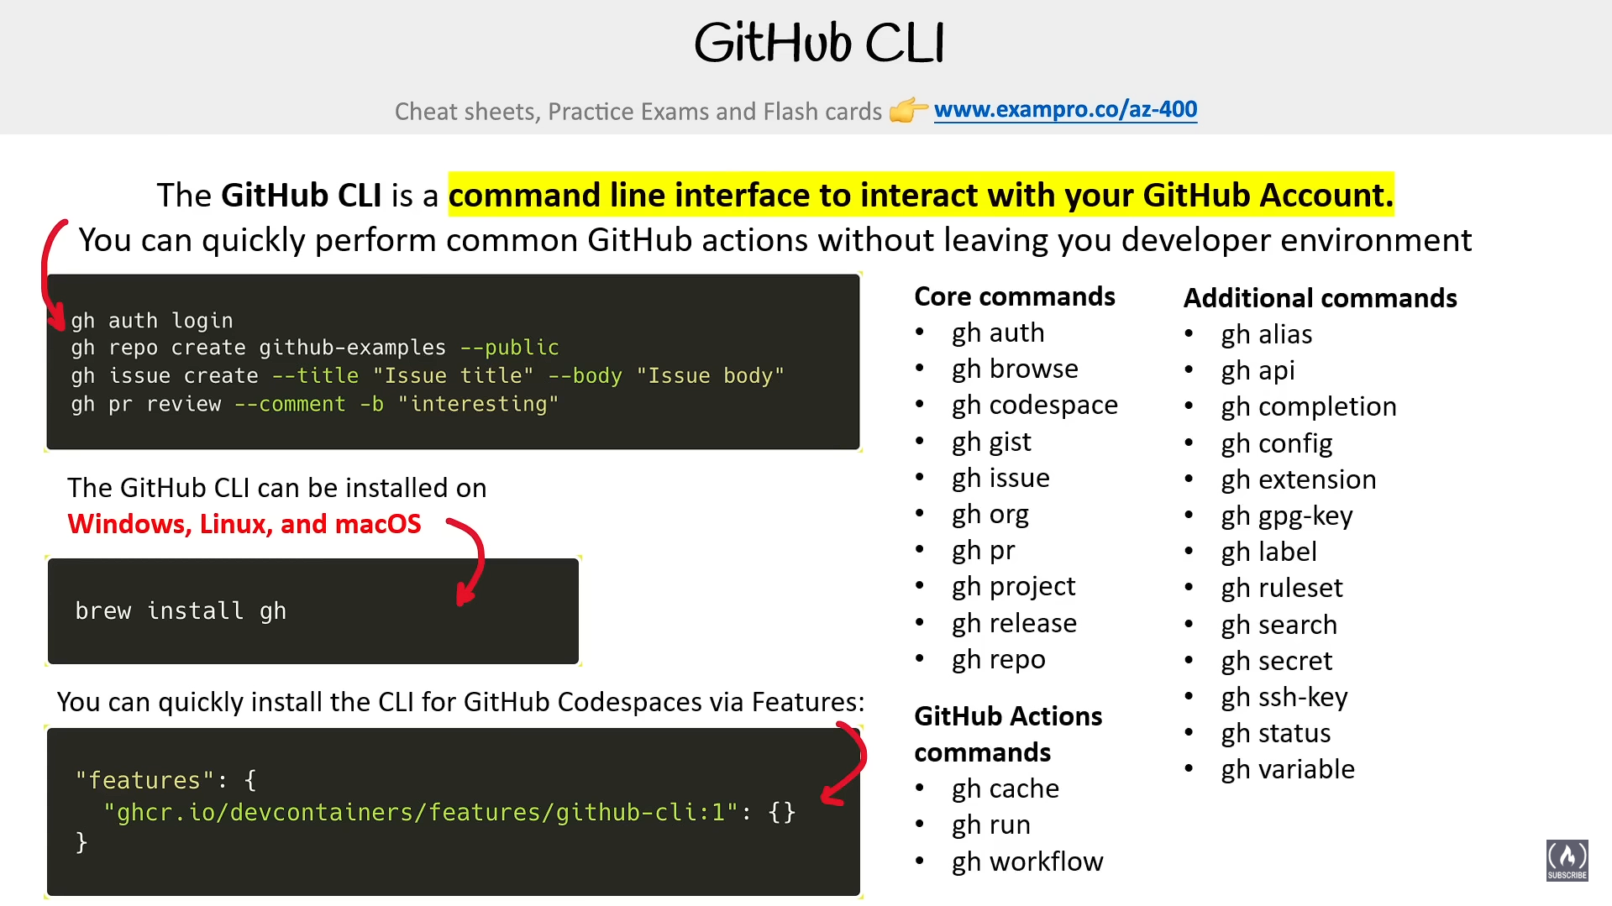

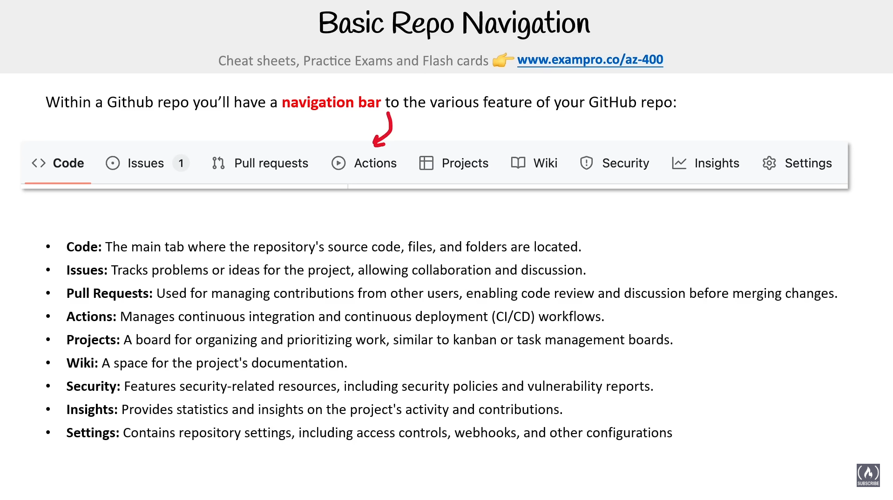

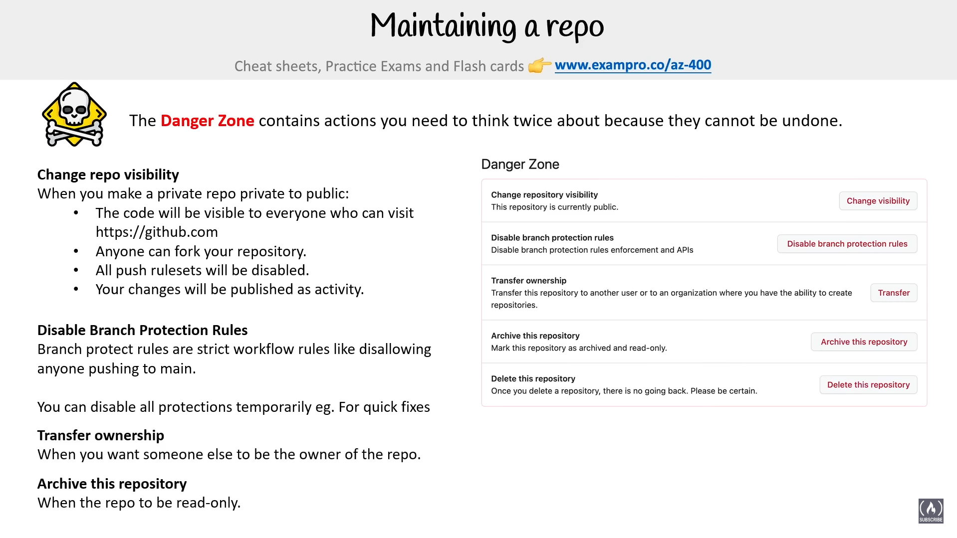

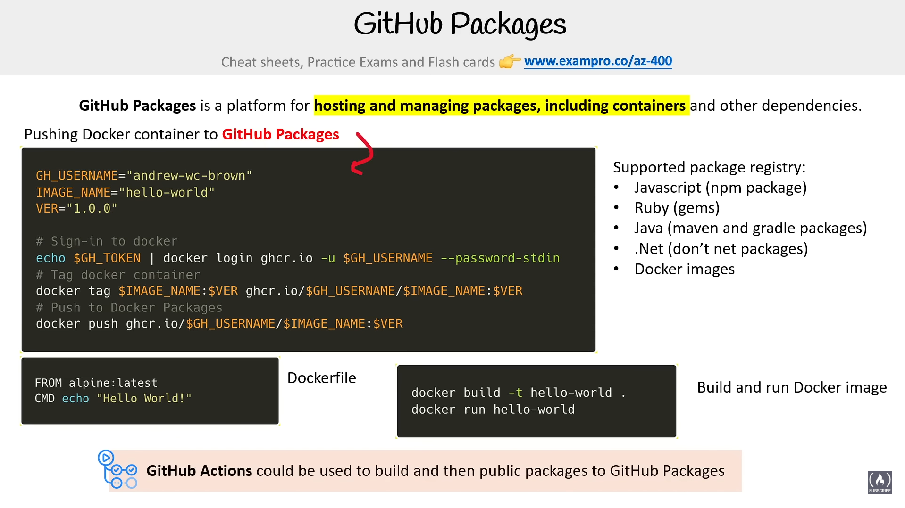

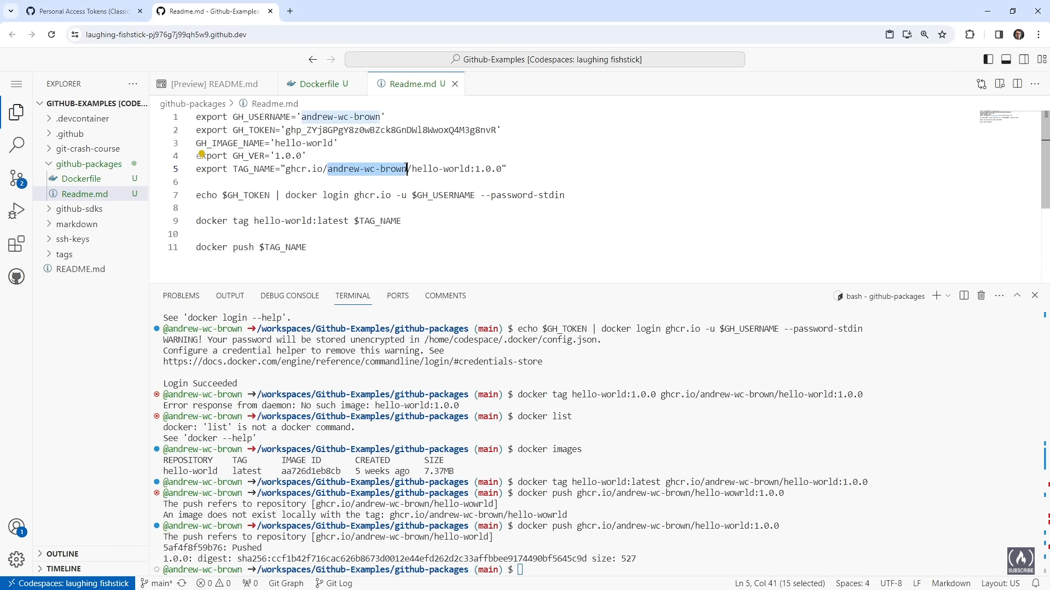

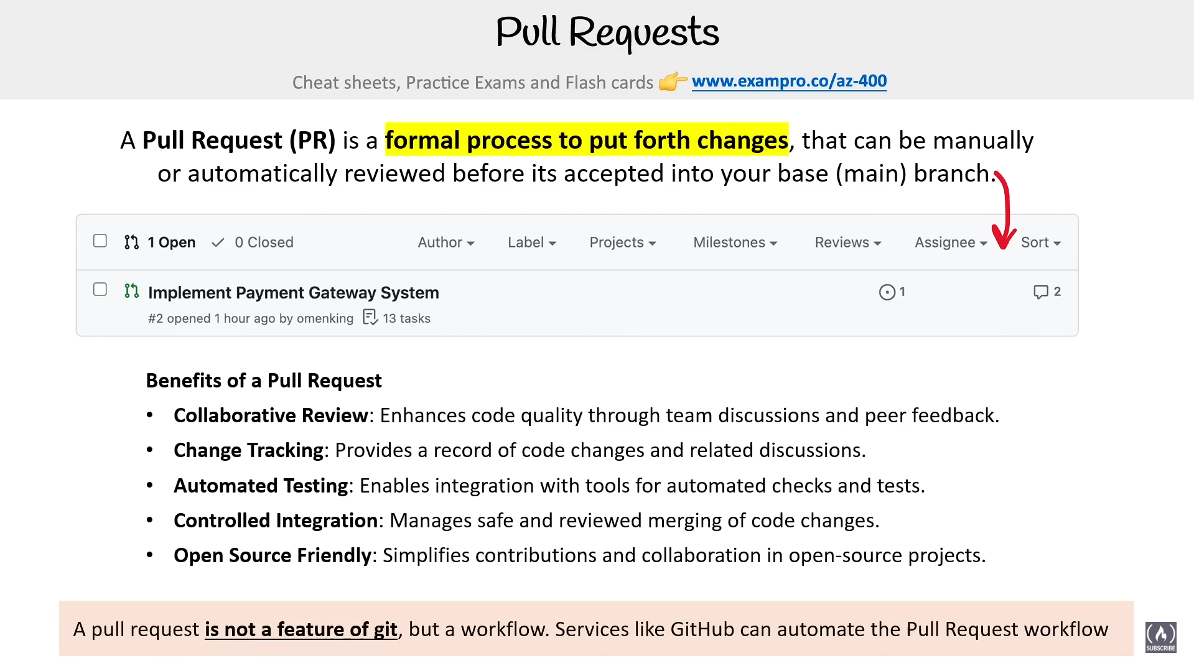

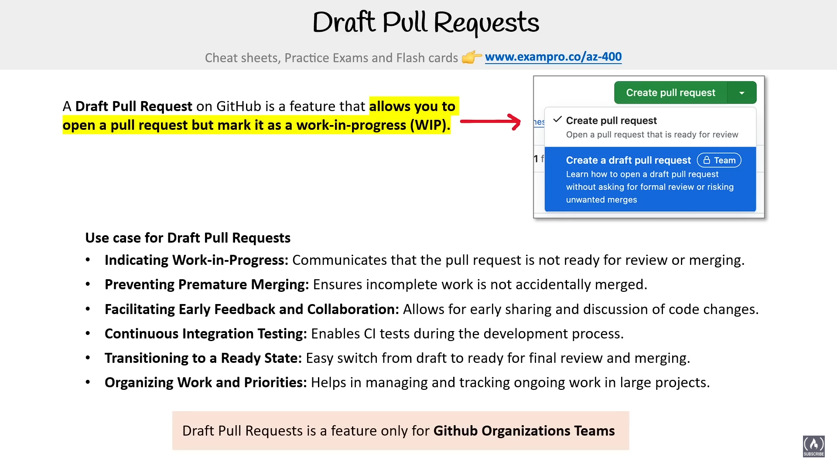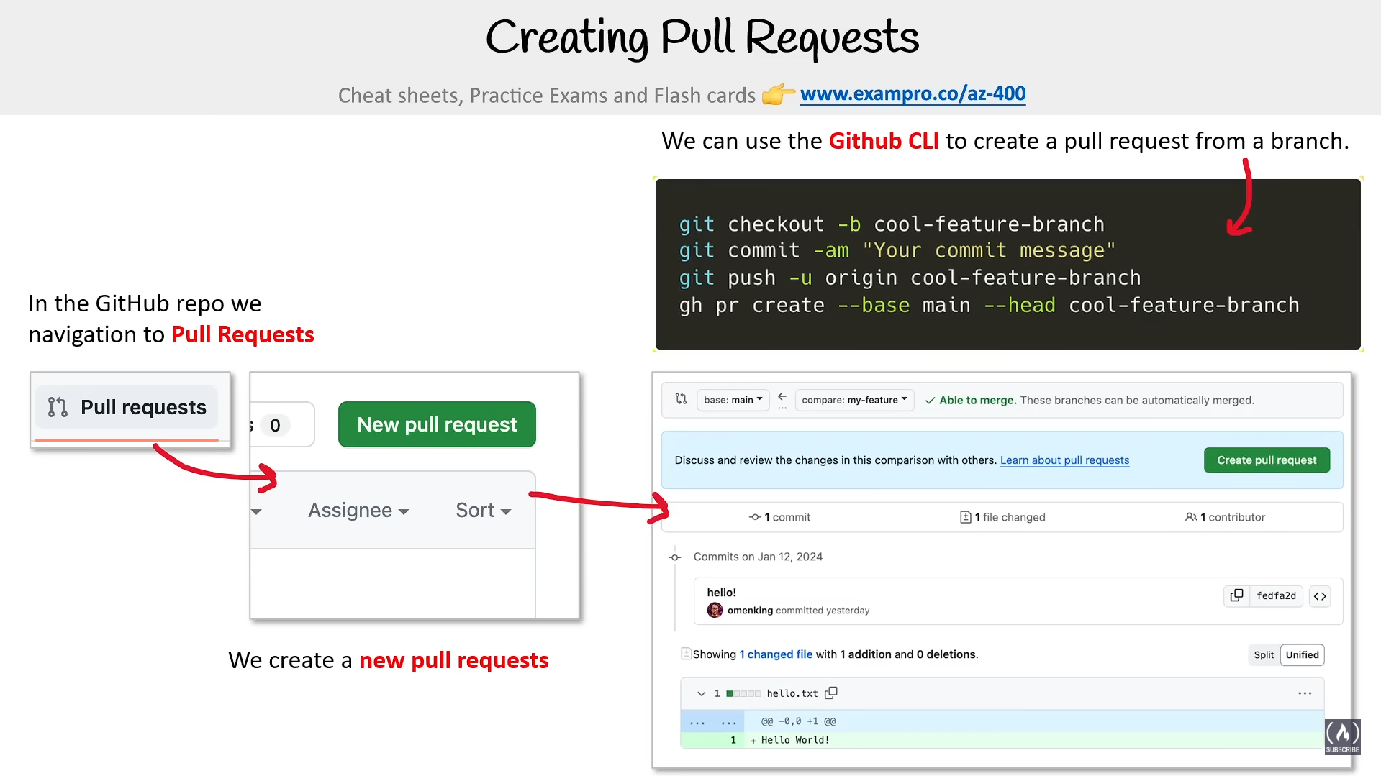

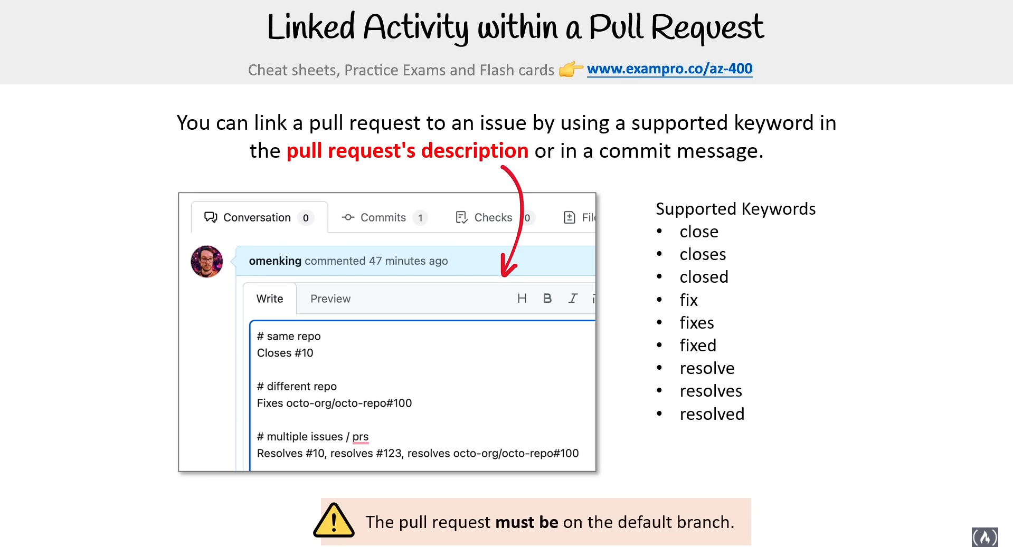

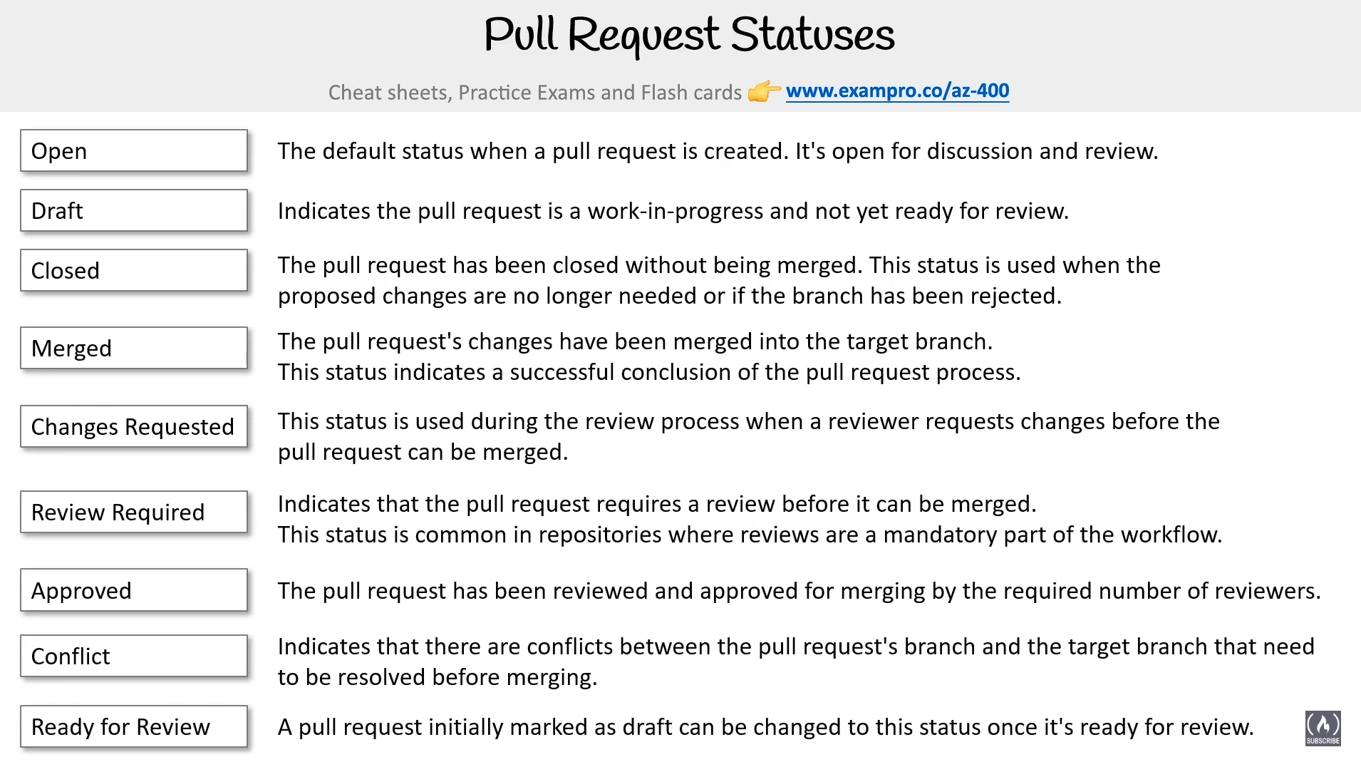

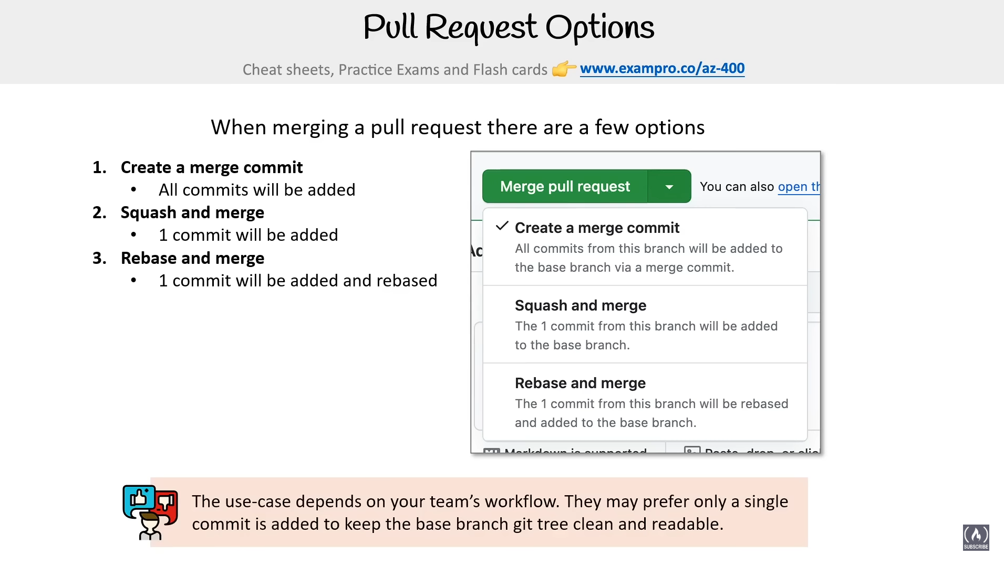

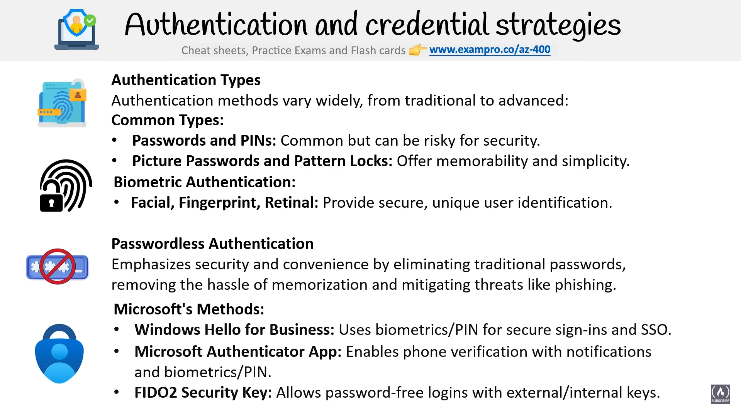

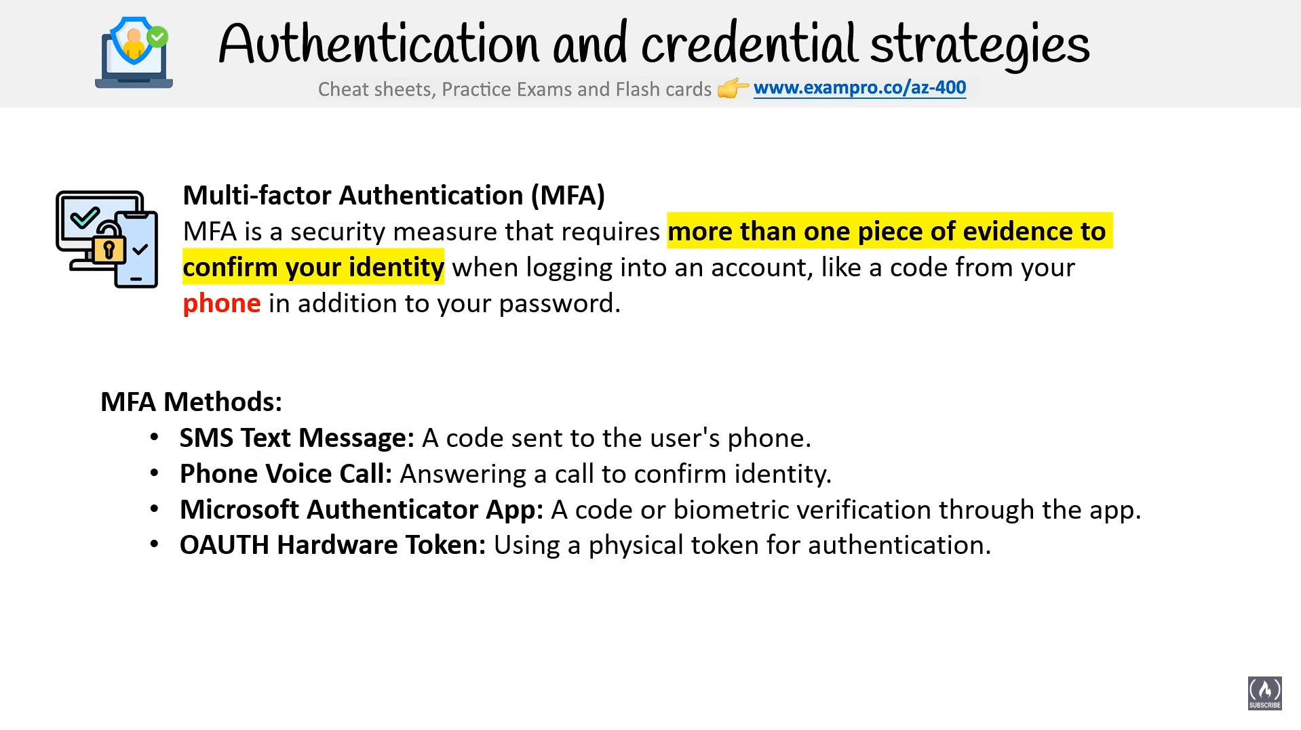

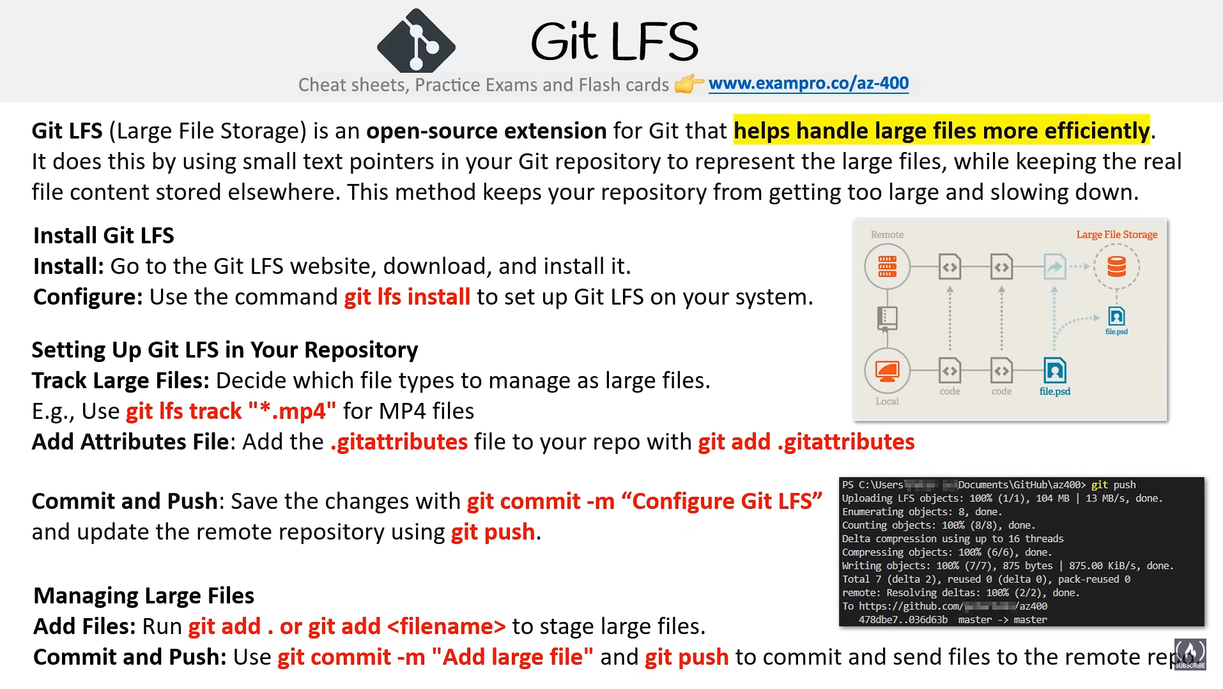

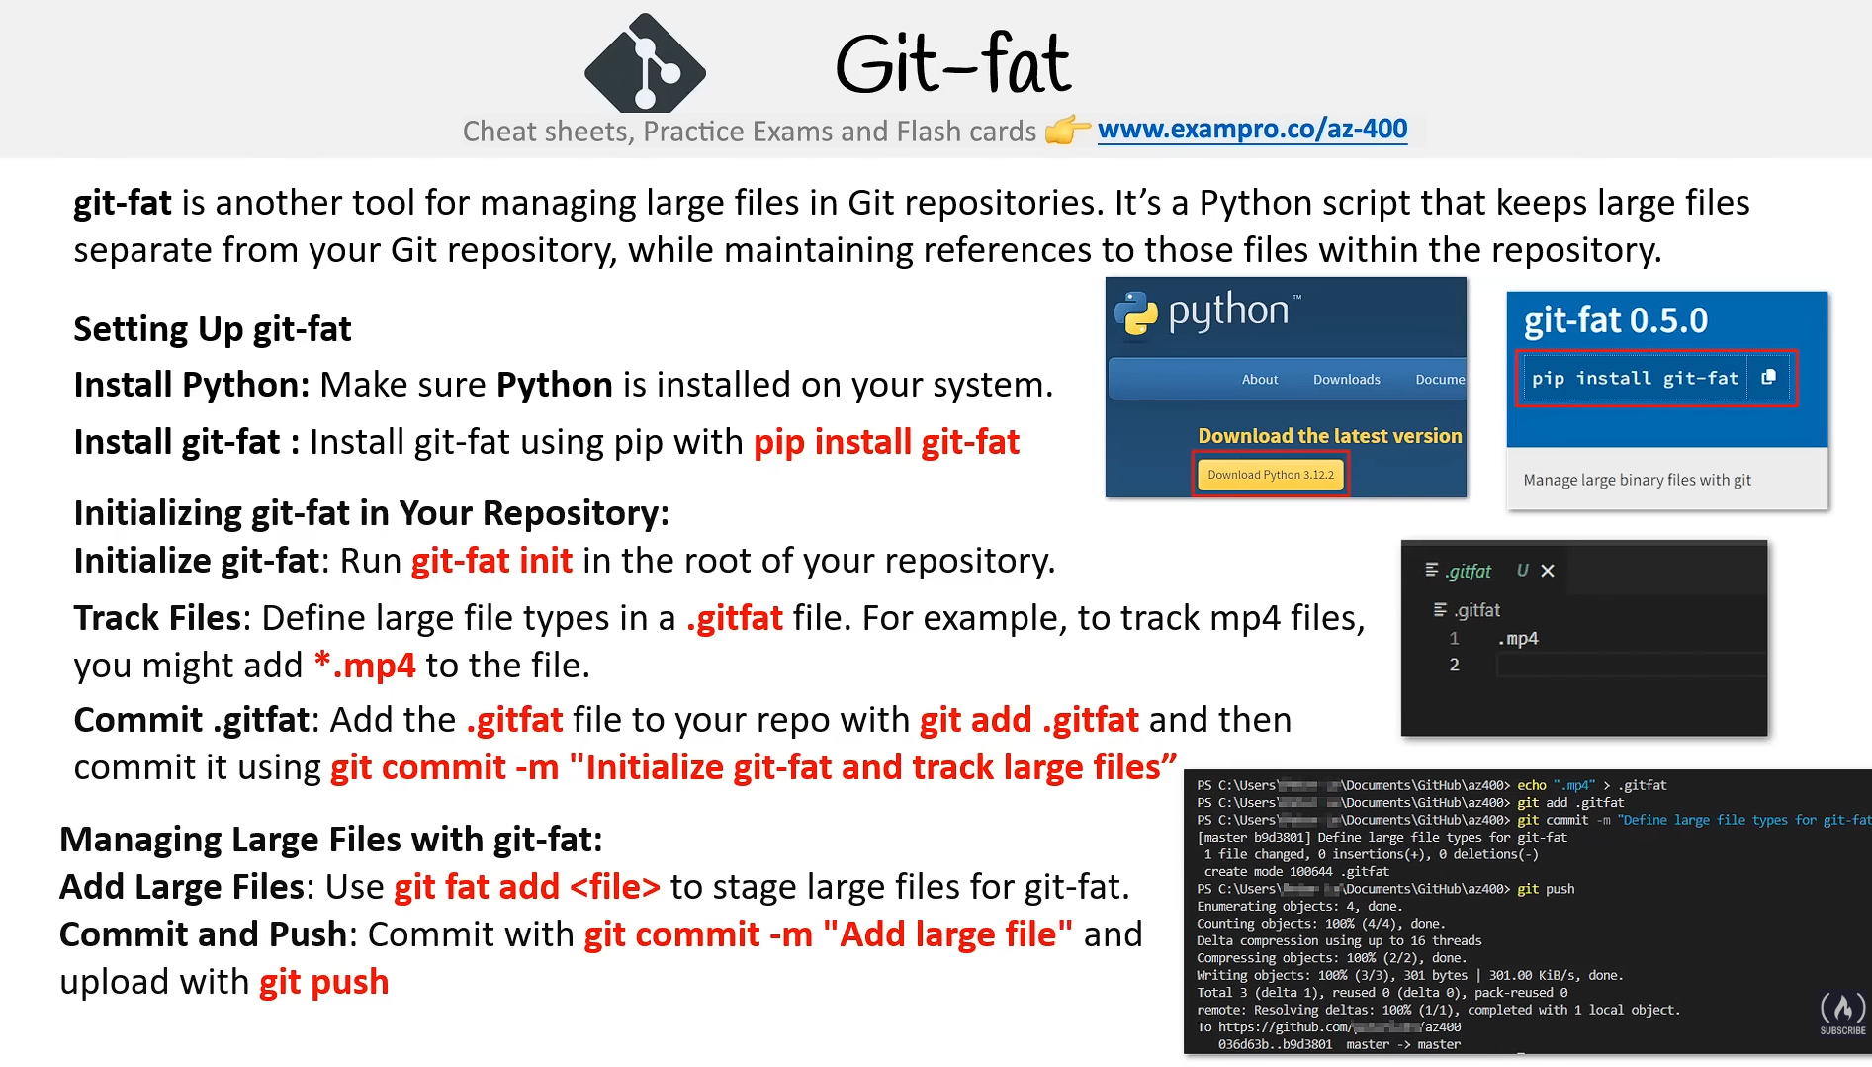

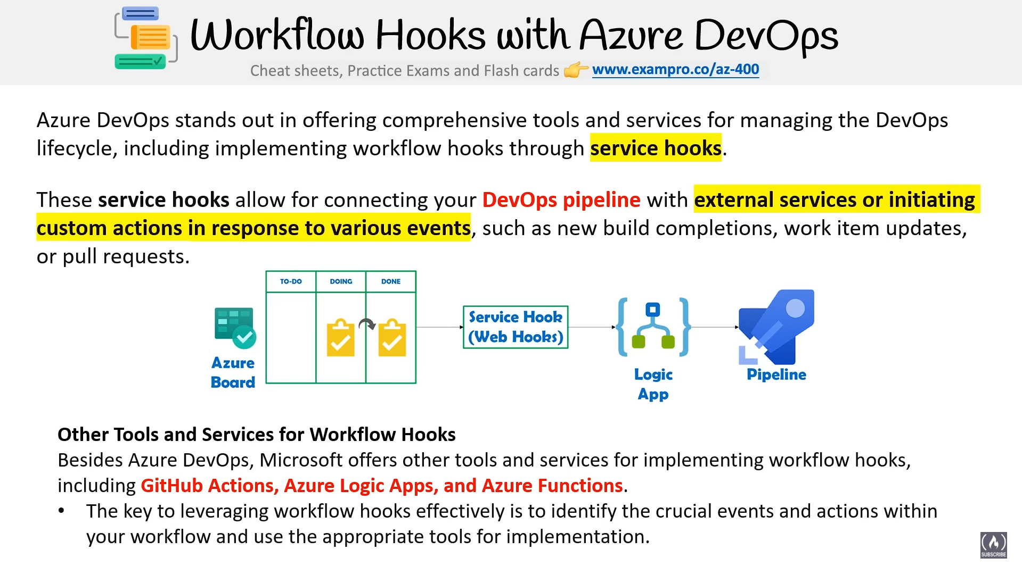

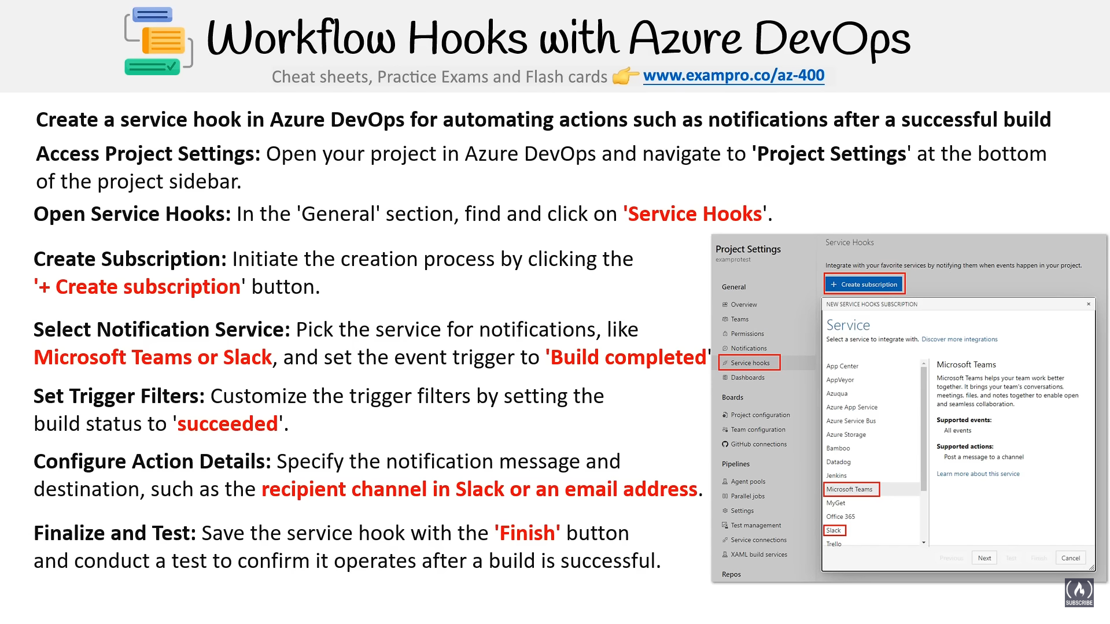

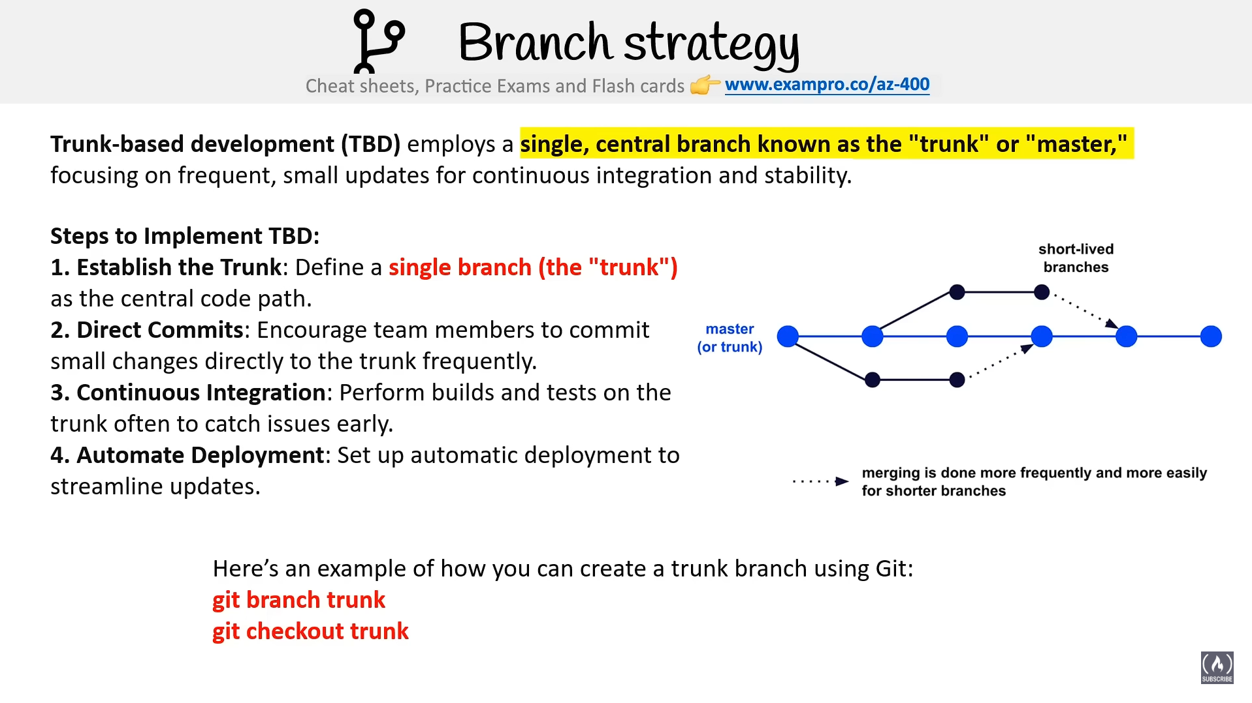

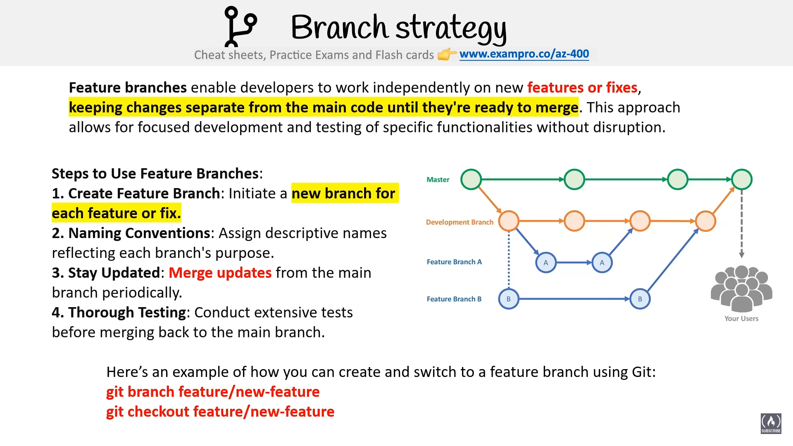

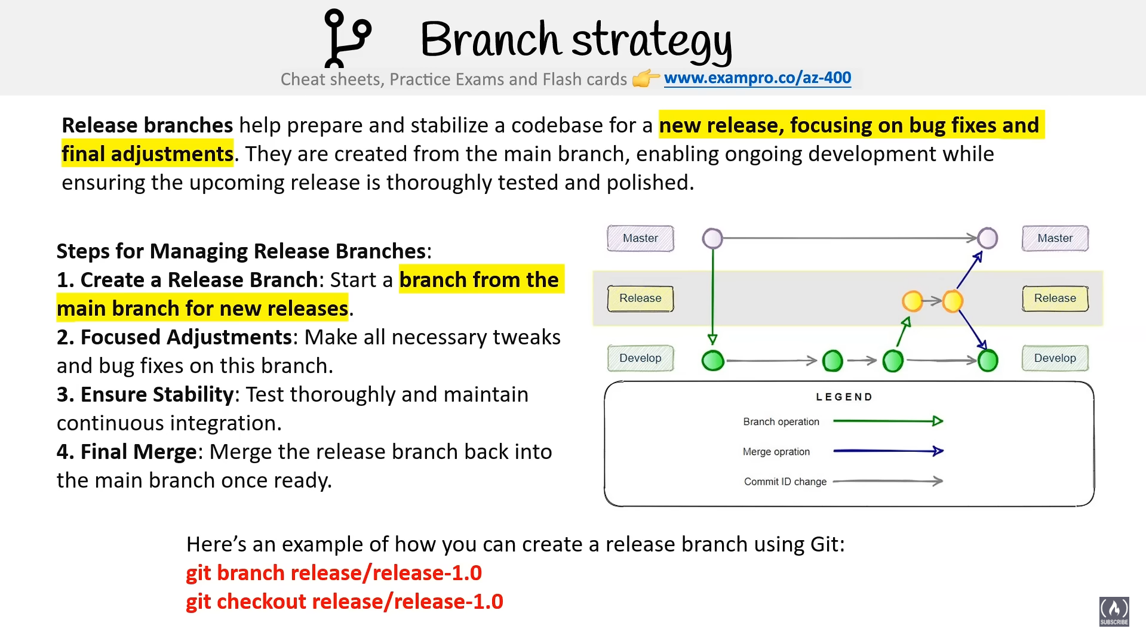

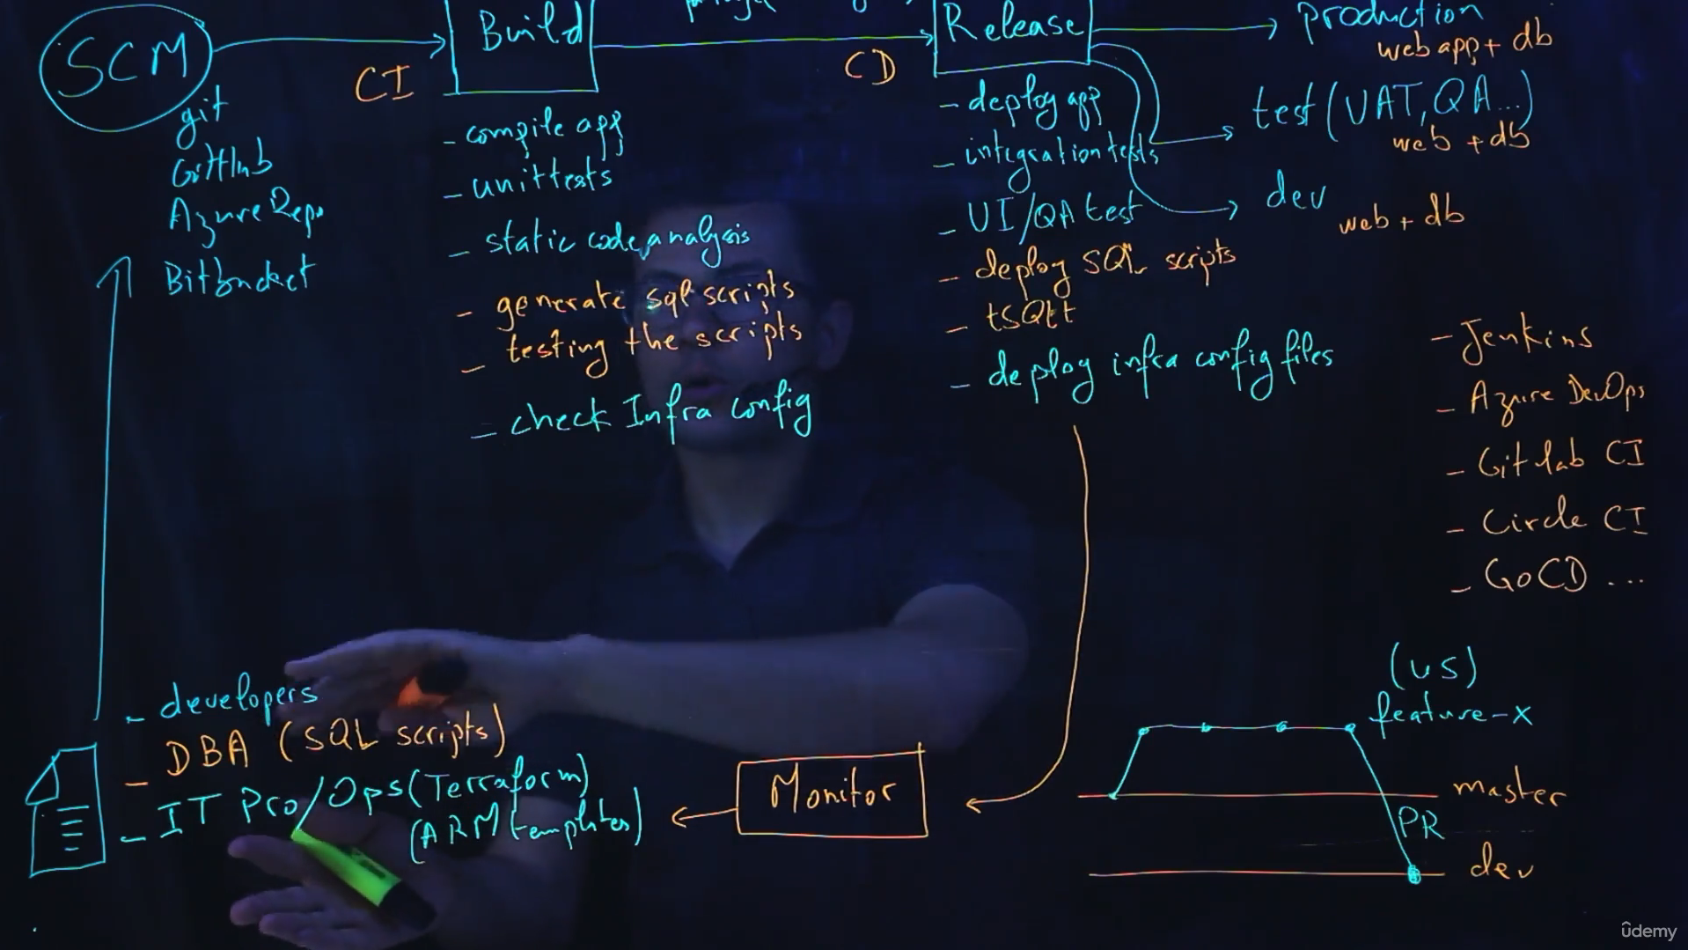

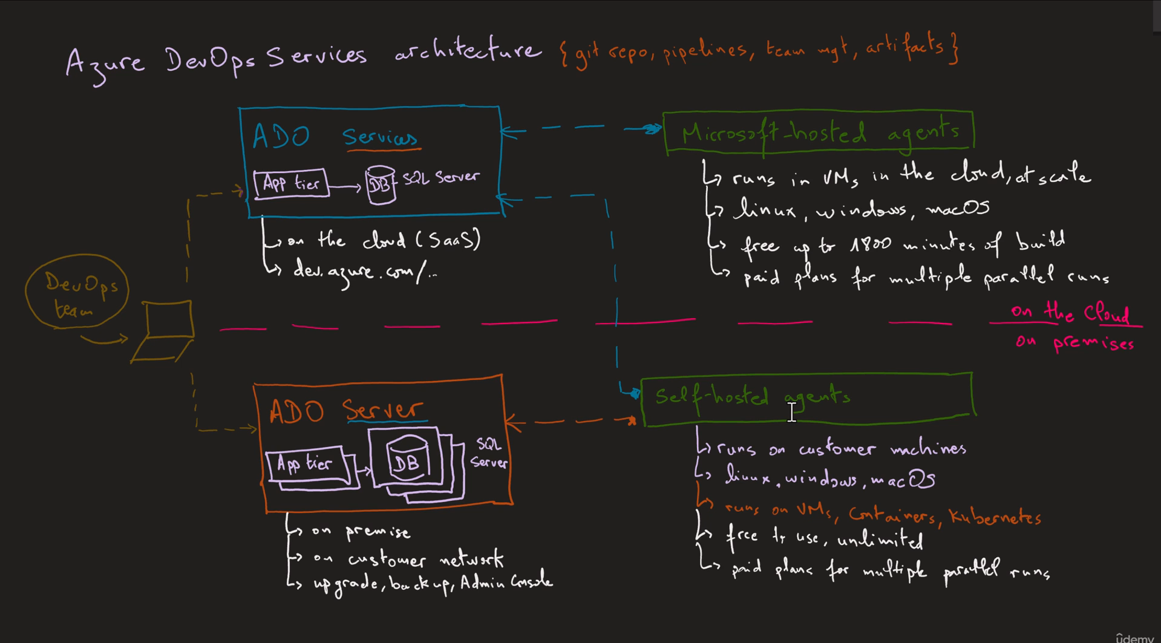

**Azure DevOps Pipelines dependencies**

**Working with Azure DevOps Pipelines Stages, Jobs and Steps**

**Introduction**

This workshop will explore some good features of Azure Pipelines for creating complex and complete pipelines. In real world scenarios, we might have multiple applications: frontend and backend, different environments: dev, test and prod. That adds more constraints to the pipelines. For example, we want to build frontend and backend in parallel. And we want to deploy into dev and test environments. But right before deploying to production, we want to add a manual approval. Using Stages, Jobs and Steps help to implement these strategies easily. Let’s see how that works.

**1. Creating a sample pipeline**

In the following pipeline we have a single step. But it has an implicit Stage and Job.

pool:

vmImage: 'ubuntu-latest'

steps:

- bash: echo "Hello world"

The above is the same as:

pool:

vmImage: 'ubuntu-latest'

stages:

- stage A:

jobs:

- job: A1

steps:

- bash: echo "Hello world"

Stages are a at the top of the tree. Each stage is an array of Jobs. Each job is a collection of steps. Stages and Jobs aren’t constrained to a limited use case. For example, in a pipeline we can use Jobs and Steps only without Stages if not needed. But here are some important facts about each one. Stages will run sequentially unless specified (using the syntax dependsOn: [] as will be shown next). Jobs within the same Stage, by default runs in parallel unless there are dependencies.

⚠ Important note:

Every Job and Stage will run in a different hosted build agent. And we can specify a different build agent for each Stage or Job.

Let’s take a sample scenario where we have a frontend and a backend to be built and deployed to both dev and prod environments. Since both apps could be built independently, we’ll build them in parallel to enhance build time. So, we’ll use 2 jobs for building the apps. The build will be triggered first, we’ll create a Stage for that. After that, we’ll deploy the apps into the dev environment. Again, we’ll use 2 jobs, one to deploy frontend and one to deploy backend. These two jobs should run after the build stage. So, we’ll put them under a new stage. Then we’ll duplicate that stage to deploy to production.

trigger:

- main

pool:

vmImage: ubuntu-latest

stages:

- stage: BuildApp

displayName: Build Apps

jobs:

- job: BuildFrontendApp

displayName: Build Frontend App

steps:

- script: echo building frontend app

displayName: build frontend app

- script: echo running unit tests for frontend app

displayName: unit tests frontend

- job: BuildBackendApp

displayName: Build Backend App

steps:

- script: echo building backend app

displayName: build backend app

- script: echo running unit tests for backend app

displayName: unit tests backend

- stage: DeployDev

displayName: Deploy to DEV environment

jobs:

- job: DeployFrontendDev

displayName: Deploy frontend to DEV

steps:

- script: echo deploying frontend app to DEV

displayName: deploy frontend app to DEV

- job: DeployBackendDev

displayName: Deploy backend to DEV

steps:

- script: echo deploying backend app to DEV

displayName: deploy backend app to DEV

- stage: DeployProd

displayName: Deploy to PROD environment

pool:

vmImage: 'macOS-10.14'

jobs:

- job: DeployFrontendProd

displayName: Deploy frontend to PROD

steps:

- script: echo deploying frontend app to PROD

displayName: deploy frontend app to PROD

- job: DeployBackendProd

displayName: Deploy backend to PROD

pool:

vmImage: 'vs2017-win2016'

steps:

- script: echo deploying backend app to PROD

displayName: deploy backend app to PROD

Let’s give it a try and see the output in Azure DevOps.



The result shows all the jobs and stages are running successfully.

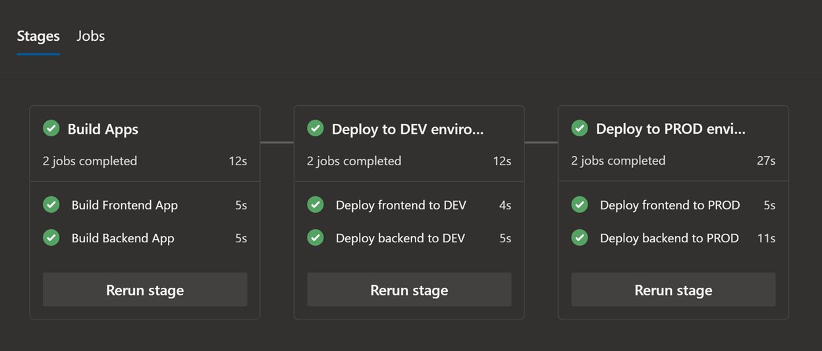

**2. Adding dependencies between stages and jobs**

We said earlier that Stages runs in sequence unless specified using the syntax dependsOn:[]. Let’s try it in action in the previous pipeline:

1. stages:
2. - stage: BuildApp
3. # code removed for brievety…
4. - stage: DeployDev
5. dependsOn: []
6. # code removed for brievety…
7. - stage: DeployProd
8. dependsOn: []
9. # code removed for brievety…

When we run this pipeline, Azure DevOps will run the 3 Stages in parallel and will show them vertically meaning there are no dependencies.

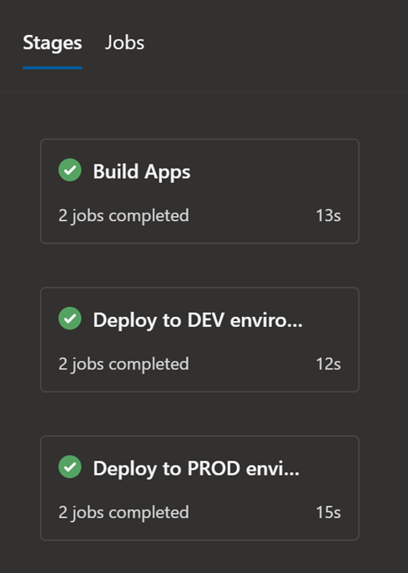

Let’s take another example where we have dependencies between Stages.

stages:

- stage: Test

- stage: DeployUS1

dependsOn: Test # this stage runs after Test

- stage: DeployUS2

dependsOn: Test # this stage runs in parallel with DeployUS1, after Test

- stage: DeployEurope

dependsOn: # this stage runs after DeployUS1 and DeployUS2

- DeployUS1

- DeployUS2

This pattern is the ‘fan-out and fan-in’.

If you want to test it, here is the complete working example:

trigger:

- main

pool:

vmImage: ubuntu-latest

stages:

- stage: Test

jobs:

- job: test

steps:

- script: echo testing app

- stage: DeployUS1

dependsOn: Test # this stage runs after Test

jobs:

- job: deploy_us1

steps:

- script: echo deploying to US1

- stage: DeployUS2

dependsOn: Test # this stage runs in parallel with DeployUS1, after Test

jobs:

- job: deploy_us2

steps:

- script: echo deploying to US2

- stage: DeployEurope

dependsOn: # this stage runs after DeployUS1 and DeployUS2

- DeployUS1

- DeployUS2

jobs:

- job: deploy_europe

steps:

- script: echo deploying to Europe

Note that dependencies works with Stages and also with Jobs.

**3. Adding conditions within stages**

We can specify the conditions under which each stage runs. By default, a stage runs if it does not depend on any other stage, or if all the stages that it depends on have completed and succeeded. We can customize this behavior by forcing a stage to run even if a previous stage fails or by specifying a custom condition.

If we customize the default condition of the preceding steps for a stage, we remove the conditions for completion and success. So, if we use a custom condition, it's common to use and(succeeded(), custom_condition) to check whether the preceding stage ran successfully. Otherwise, the stage runs regardless of the outcome of the preceding stage.

Example to run a stage based upon the status of running a previous stage:

stages:

- stage: A

# stage B runs if A fails

- stage: B

condition: failed()

# stage C runs if B succeeds

- stage: C

dependsOn:

- A

- B

condition: succeeded('B')

Example of using a custom condition:

stages:

- stage: A

- stage: B

condition: and(succeeded(), eq(variables['build.sourceBranch'], 'refs/heads/main'))

More examples of custom conditions could be found in this link:

[docs.microsoft.com/en-us/azure/devops/pipelines/process/conditions](https://docs.microsoft.com/en-us/azure/devops/pipelines/process/conditions?view=azure-devops&tabs=yaml)

